Series 2 Experimental
General Chemistry. Reagents purchased were used as received, unless otherwise noted. Purification of intermediates and final compounds was performed using silica gel or reverse phase chromatography using the Biotage® Selekt flash purification system. LCMS analysis was performed using an Agilent1260 Infinity II reverse phase HPLC and MSD with InfinityLab Poroshell 120 columns (EC-C18, 2.7 μm, ID 4.6 mm, length 50 mm), using a diode array detector at254 nm and280 nm and electrospray ionization. All compounds tested had a purity of > 95% as measured by LCMS, unless otherwise noted. ¹H NMR spectra were obtained with Bruker NMR systems, operating at either 400 or 500 MHz at room temperature. Chemical shifts (δ, ppm) are reported relative to the solvent peak (CDCl₃: 7.26 [¹H]; DMSO-d₆: 2.50 [¹H]; or CD₃OD: 3.31 [¹H]). Data for ¹H NMR spectra are reported as follows: chemical shift (ppm), multiplicity (s for singlet, d for doublet, t for triplet, dd for doublet of doublet, m for multiplet), coupling constant (Hz), and integration.
General procedure A for the synthesis of 2-(pyridyl)imidazoles. The corresponding 2-bromo-1-(pyridyl)ethan-1-one hydrobromide (1 equiv.), heterocycloalkenyl or heteroaryl amine (1 – 2 equiv.), and Na₂CO₃ (2 – 4 equiv.) were stirred in DMF (15 – 20 mL) at 85 °C for 18 h. After cooling to room temperature, the reaction mixture was partitioned between dichloromethane and water. The organic layer was separated, dried over Na₂SO₄, filtered and concentrated under reduced pressure to give a residue that was purified by flash chromatography on silica.
General procedure B for the synthesis of 3-bromo-2-(pyridyl)imidazoles. To a solution of the corresponding 2-(pyridyl)imidazole (1 equiv.) in dichloromethane (3 – 10 mL) was added N-bromosuccinimide (1 equiv.) and the mixture stirred at 25 °C for 1 h. On completion, the volatiles were evaporated. The residue was diluted with ethyl acetate and washed with saturated solution of NaHCO₃ and brine. The organic phase was dried over Na₂SO₄, filtered and concentrated under reduced pressure to afford the desired product, which was used without further purification.
General procedure C for the synthesis of 3-Aryl-2-(pyridyl)imidazoles. A reaction vial was charged with the corresponding 3-bromo-2-(pyridyl)imidazole (1 equiv.), the appropriate aryl boronic acid or pinacol boronic ester (1.3 equiv.) and Pd(PPh₃)₄ (0.12 equiv.). The vial was sealed with a Teflon septum, evacuated and backfilled with nitrogen (this sequence was carried out three times). Under an inert atmosphere, a mixture of toluene and methanol (3:1, v/v, 0.2 M) was added via syringe, followed by the addition of 2 M aqueous Na₂CO₃ (4 equiv.). The mixture was heated at 120 °C for 18 h or in the microwave at 120 °C for 30 minutes. After cooling to room temperature, the mixture was either diluted with dichloromethane and the organic layer was washed with brine, dried over Na₂SO₄, filtered and concentrated under reduced pressure; or alternatively, the reaction mixture was diluted with MeOH, filtered through celite, and concentrated. The crude residue was purified by flash chromatography on silica and the product triturated to afford a fine powder.
General procedure C for the synthesis of imidazopyridine derivatives. A dried round-bottom flask was charged with appropriate diaminopyridine (1eq.), sodium bicarbonate (1.05 eq.) and methanol under an atmosphere of dry argon. Appropriate bromoacetophenone (1.05 eq.) was added slowly at room temperature. Then, the reaction mixture was stirred at reflux for 12 h. The reaction mixture was cooled to room temperature, diluted with water, organic solvent evaporated, and reaming water extracted with ethyl acetate. After drying over sodium sulfate and solvent evaporation, the product was purified on a column of silica gel.
General procedure D for Mannich reaction. A starting material solution of imidazopyridine derivative (1.0 mmol) and the appropriate amine derivative (1.2 mmol) were dissolved in 10 ml of dichloromethane. Thereafter, acetic acid (0.8 ml) and 37% aqueous formaldehyde (0.2 ml) were added and the whole reaction mixture was stirred overnight. The reaction was quenched with water (16.0 ml) and was extracted with dichloromethane. After drying and removing of the solvent the crude products were purified by column chromatography.
General procedure E for N-alkylation of anilines. Under nitrogen, a solution of aniline (0.2 g, 1 eq.), iodoalkyl (1.1 eq) and K₂CO₃ (0.12 eq) in NMP (20 mL) was stirred at 100 °C. After 3 days, the solution was evaporated under reduced pressure, added water and extracted with ethyl acetate. Then, the crude product was purified by column chromatography (silica, ethyl acetate/hexane, 1:100) to give de desired product (~78 % yield).
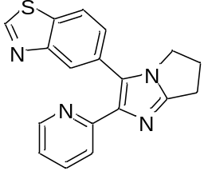
5-(2-(Pyridin-2-yl)-6,7-dihydro-5H-pyrrolo[1,2-a]imidazol-3-yl)benzo[d]thiazole (OSA_000835). The title compound was prepared according to General Procedure C using 3-bromo-2-(pyridin-2-yl)-6,7-dihydro-5H-pyrrolo[1,2-a]imidazole (70 mg) and 5-(4,4,5,5-tetramethyl-1,3,2-dioxaborolan-2-yl)benzo[d]thiazole. The crude material was purified by flash chromatography (1-20% MeOH:DCM), then triturated with 1:10 EtOAc:Hex to afford the title compound as an orange solid (10 mg, 12%).
HRMS [M+H]⁺
¹H NMR (500 MHz, CHLOROFORM-d) δ ppm 9.04 (s, 1 H) 8.43 (d, J=5.0 Hz, 1 H) 8.22 (d, J=1.3 Hz, 1 H) 7.95 (d, J=8.2 Hz, 1 H) 7.71 (d, J=7.9 Hz, 1 H) 7.53 - 7.62 (m, 2 H) 7.06 (ddd, J=7.4, 4.9, 0.9 Hz, 1 H) 4.04 (t, J=7.1 Hz, 2 H) 3.05 (t, J=7.6 Hz, 2 H) 2.67 (quin, J=7.3 Hz, 2 H)
¹³C NMR (500 MHz, CHLOROFORM-d) δ ppm 23.6, 26.2, 44.7, 121.3, 121.4, 121.7, 123.5, 127.1, 127.5, 129.5, 133.1, 136.1, 141.7, 149.1, 153.5, 154.1, 154.3, 154.6
ELN Link: https://au-mynotebook.labarchives.com/share/Dana%2520Klug/MzE3LjJ8Njk2ODYvMjQ0L1RyZWVOb2RlLzI3NjE2MjY4MzJ8ODA1LjE5OTk5OTk5OTk5OTk=
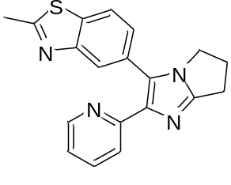
2-Methyl-5-(2-(pyridin-2-yl)-6,7-dihydro-5H-pyrrolo[1,2-a]imidazol-3-yl)benzo[d]thiazole (OSA_000836).The title compound was prepared according to General Procedure C using 3-bromo-2-(pyridin-2-yl)-6,7-dihydro-5H-pyrrolo[1,2-a]imidazole (65 mg) and 2-methyl-5-(4,4,5,5-tetramethyl-1,3,2-dioxaborolan-2-yl)benzo[d]thiazole. The crude material was purified by flash chromatography (1-20% MeOH:DCM), then triturated with 1:10 EtOAc:Hex to afford the title compound as a tan solid (24 mg, 29%).
HRMS [M+H]⁺ 333.1167 m/z
¹H NMR (500 MHz, CHLOROFORM-d) δ ppm 8.45 (d, J=4.1 Hz, 1 H) 8.02 (d, J=0.9 Hz, 1 H) 7.80 (d, J=8.5 Hz, 1 H) 7.65 (d, J=7.9 Hz, 1 H) 7.56 (td, J=7.7, 1.9 Hz, 1 H) 7.44 (dd, J=8.4, 1.4 Hz, 1 H) 7.05 (ddd, J=7.4, 4.9, 0.9 Hz, 1 H) 4.01 (t, J=7.1 Hz, 2 H) 3.03 (t, J=7.6 Hz, 2 H) 2.86 (s, 3 H) 2.65 (quin, J=7.3 Hz, 2 H)
¹³C NMR (500 MHz, CHLOROFORM-d) δ ppm 20.2, 23.6, 26.2, 44.7, 121.2, 121.3, 121.4, 122.4, 126.4, 127.3, 129.0, 135.1, 136.0 141.5, 149.2, 153.6, 154.1, 154.2, 167.7
ELN Link: https://au-mynotebook.labarchives.com/share/Dana%2520Klug/MzE4LjV8Njk2ODYvMjQ1L1RyZWVOb2RlLzI5MTExMzY4M3w4MDguNQ==
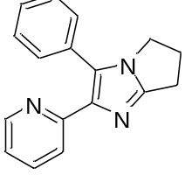
3-Phenyl-2-(pyridin-2-yl)-6,7-dihydro-5H-pyrrolo[1,2-a]imidazole (OSA_000870).The title compound was prepared according to General Procedure C using 3-bromo-2-(pyridin-2-yl)-6,7-dihydro-5H-pyrrolo[1,2-a]imidazole (75 mg) and phenylboronic acid. The crude material was purified by flash chromatography (1-10% MeOH:DCM), then repurified by reverse phase chromatography (5-100% MeOH:H₂O) to afford the title compound as a tan solid (18 mg, 24%).
HRMS [M+H]⁺ 262.1354 m/z
¹H NMR (500 MHz, CHLOROFORM-d) δ ppm 8.49 (d, J=4.7 Hz, 1 H) 7.51 - 7.61 (m, 2 H) 7.42 - 7.46 (m, 2 H) 7.39 (t, J=7.4 Hz, 2 H) 7.32 - 7.37 (m, 1 H) 7.02 - 7.08 (m, 1 H) 3.97 (t, J=7.1 Hz, 2 H) 3.01 (t, J=7.6 Hz, 2 H) 2.63 (quin, J=7.3 Hz, 2 H).
¹³C NMR (500 MHz, CHLOROFORM-d) δ ppm 23.6, 26.2, 44.6, 121.1, 121.4, 127.8, 128.4, 129.2, 131.1, 135.8, 141.4, 149.3, 154.0, 154.2.
ELN Link: https://au-mynotebook.labarchives.com/share/Dana%2520Klug/MzQ0LjV8Njk2ODYvMjY1L1RyZWVOb2RlLzEyMTIyMzQ2OTh8ODc0LjU=
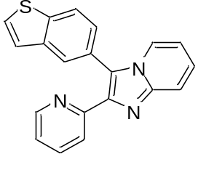
3-(Benzo[b]thiophen-5-yl)-2-(pyridin-2-yl)imidazo[1,2-a]pyridine (OSA_000871).The title compound was prepared according to General Procedure C using 3-bromo-2-(pyridin-2-yl)imidazo[1,2-a]pyridine (100 mg) and 2-(benzo[b]thiophen-5-yl)-4,4,5,5-tetramethyl-1,3,2-dioxaborolane. The crude material was purified by flash chromatography (1-15% MeOH:DCM), then repurified by flash chromatography (20-100% EtOAc:Hex - 0-15% MeOH:DCM). The resulting dark yellow semisolid was purified by reverse phase chromatography (5-100% MeOH:H₂O), concentrated, and triturated with 1:10 EtOAc:Hex to afford the title compound as a dull yellow solid (39 mg, 33%).
HRMS [M+H]⁺ 328.0909 m/z
¹H NMR (500 MHz, CHLOROFORM-d) δ ppm 8.57 (d, J=5.0 Hz, 1 H) 8.04 (d, J=8.2 Hz, 1 H) 8.02 (d, J=6.9 Hz, 1 H) 7.99 (s, 1 H) 7.84 (d, J=8.8 Hz, 1 H) 7.72 (d, J=7.9 Hz, 1 H) 7.54 - 7.62 (m, 2 H) 7.45 (dd, J=8.2, 1.3 Hz, 1 H) 7.40 (d, J=5.4 Hz, 1 H) 7.30 (t, J=7.6 Hz, 1 H) 7.14 (dd, J=7.4, 4.9 Hz, 1 H) 6.81 (t, J=6.8 Hz, 1 H)
¹³C NMR (400 MHz, CHLOROFORM-d) δ ppm 112.9, 117.9, 122.2, 122.7, 123.1, 123.4, 123.7, 124.0, 125.4, 125.5, 125.9, 126.8, 127.5, 136.1, 140.29, 140.33, 141.2, 144.6, 149.7, 152.8
ELN Link: https://au-mynotebook.labarchives.com/share/Dana%2520Klug/MzU0LjkwMDAwMDAwMDAwMDAzfDY5Njg2LzI3My9UcmVlTm9kZS82MTYxNDQyMjd8OTAwLjk=
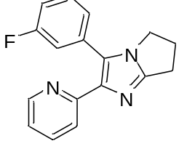
3-(3-Fluorophenyl)-2-(pyridin-2-yl)-6,7-dihydro-5H-pyrrolo[1,2-a]imidazole(OSA_000872).The title compound was prepared according to General Procedure C using 3-bromo-2-(pyridin-2-yl)-6,7-dihydro-5H-pyrrolo[1,2-a]imidazole (75 mg) and (3-fluorophenyl)boronic acid. The crude material was purified by flash chromatography (1-10% MeOH:DCM, step gradient). The resulting orange solid was triturated with 1:10 EtOH:Hex, then with a minimal amount of MeOH to afford a cream solid, which was then purified by reverse phase chromatography (5-100% ACN:H₂O) to afford the title compound as a tan solid (13 mg, 16%).
HRMS [M+H]⁺ 280.1251 m/z
¹H NMR (500 MHz, CHLOROFORM-d) δ ppm 8.47 (dd, J=4.7, 0.6 Hz, 1 H) 7.69 (d, J=7.9 Hz, 1 H) 7.61 (td, J=7.7, 1.9 Hz, 1 H) 7.35 (td, J=8.0, 6.1 Hz, 1 H) 7.21 (d, J=7.6 Hz, 1 H) 7.16 - 7.20 (m, 1 H) 7.09 (ddd, J=7.4, 4.9, 0.9 Hz, 1 H) 7.04 (td, J=6.6, 1.9 Hz, 1 H) 3.99 (t, J=7.1 Hz, 2 H) 3.04 (t, J=7.6 Hz, 2 H) 2.65 (quin, J=7.3 Hz, 2 H)
¹³C NMR (500 MHz, CHLOROFORM-d) δ ppm 23.6, 26.4, 44.9, 114.8 (d, J=21.1 Hz), 116.2 (d, J=22.0 Hz), 121.5 (d, J=1.8 Hz), 124.9 (d, J=2.7 Hz), 126.6 (d, J=1.8 Hz), 129.9 (d, J=8.2 Hz), 132.78 (d, J=8.2 Hz), 136.2, 141.2, 149.1, 153.4, 154.1, 161.6, 163.6
ELN Link: https://au-mynotebook.labarchives.com/share/Dana%2520Klug/MzczLjF8Njk2ODYvMjg3L1RyZWVOb2RlLzM2NTE1NDYxMjN8OTQ3LjA5OTk5OTk5OTk5OTk=
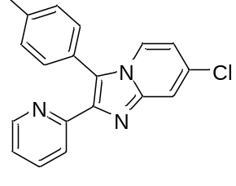
7-Chloro-2-(pyridin-2-yl)-3-(p-tolyl)imidazo[1,2-a]pyridine (OSA_000978).
3-Bromo-7-chloro-2-(pyridin-2-yl)imidazo[1,2-a]pyridine (75 mg, 0.246 mmol), p-tolylboronic acid (40 mg, 0.294 mmol), and PdCl₂(dppf)∙CH₂Cl₂ (20 mg, 0.024 mmol) were combined in a microwave vial that was filled with argon and evacuated three times. A 2M aqueous Na₂CO₃ solution (0.60 ml, 1.20 mmol) was added, followed by the additon of 3:1 PhMe:EtOH (1.2 ml, 0.2 M). The reaction was run in the microwave at 120 ºC for 15 mins. The reaction was cooled to room temperature, diluted with MeOH, filtered through celite, and concentrated. The crude material was purified by flash chromatography (1-15% 5% NH₄OH/MeOH:DCM), then by reverse phase chromatography (5-100% ACN:H₂O) to afford the title compound as tan solid (27 mg, 34%).
HRMS [M+H]⁺ 320.0949 m/z
¹H NMR (500 MHz, CHLOROFORM-d) δ ppm 8.62 (d, J=4.7 Hz, 1 H) 7.92 (d, J=7.6 Hz, 1 H) 7.87 (br. s., 1 H) 7.68 (d, J=7.9 Hz, 1 H) 7.63 (t, J=7.6 Hz, 1 H) 7.34 - 7.39 (m, 4 H) 7.18 (dd, J=6.8, 5.5 Hz, 1 H) 6.82 (dd, J=7.9, 0.9 Hz, 1 H) 2.48 (s, 3 H)
¹³C NMR (500 MHz, CHLOROFORM-d) δ ppm 21.5, 115.1, 116.3, 122.7, 122.9, 123.6, 124.2, 125.2, 130.2, 130.6, 132.8, 136.4, 139.6, 140.6, 143.8, 149.7, 151.5
ELN Link: https://au-mynotebook.labarchives.com/share/Dana%2520Klug/MzkxLjN8Njk2ODYvMzAxL1RyZWVOb2RlLzM5NTY5ODU3Mjd8OTkzLjM=
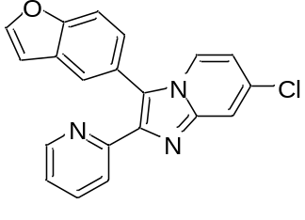
3-(Benzofuran-5-yl)-7-chloro-2-(pyridin-2-yl)imidazo[1,2-a]pyridine (OSA_000985).
3-Bromo-7-chloro-2-(pyridin-2-yl)imidazo[1,2-a]pyridine (75 mg, 0.246 mmol), 2-(benzofuran-5-yl)-4,4,5,5-tetramethyl-1,3,2-dioxaborolane (72 mg, 0.295 mmol), and PdCl₂(dppf)∙CH₂Cl₂ (20 mg, 0.024 mmol) were combined in a microwave vial that was filled with argon and evacuated three times. A 2M aqueous Na₂CO₃ solution (0.60 ml, 1.20 mmol) was added, followed by the additon of 3:1 PhMe:EtOH (1.2 ml, 0.2 M). The reaction was run in the microwave at 120 ºC for 15 mins. The reaction was cooled to room temperature, diluted with EtOAc, filtered through celite, and concentrated. The crude material was purified by flash chromatography (1-10% MeOH:DCM), then repurified by reverse phase chromatography (5-100% MeOH:H₂O) to afford the title compound as a light beige solid (14 mg, 17%).
HRMS [M+H]⁺346.0739 m/z
¹H NMR (500 MHz, CHLOROFORM-d) δ ppm 6.87 (dd, J=2.2, 0.6 Hz, 1 H) 6.88 (d, J=7.6 Hz, 1 H) 7.20 (dd, J=6.8, 4.9 Hz, 1 H) 7.39 (dd, J=8.4, 1.7 Hz, 1 H) 7.63 (td, J=7.6, 1.4 Hz, 1 H) 7.68 - 7.74 (m, 2 H) 7.75 (d, J=1.3 Hz, 1 H) 7.77 (d, J=2.2 Hz, 1 H) 7.91 (d, J=7.6 Hz, 1 H) 8.03 (br. s., 1 H) 8.60 (d, J=4.1 Hz, 1 H)
¹³C NMR (500 MHz, CHLOROFORM-d) δ ppm 106.9, 112.8, 115.8, 116.0, 122.1, 122.9, 123.0, 123.8, 123.9, 124.3, 127.0, 128.7, 134.1, 136.8, 139.3, 143.2, 146.4, 149.7, 150.4, 155.4
ELN Link: https://au-mynotebook.labarchives.com/share/Dana%2520Klug/NDAxLjd8Njk2ODYvMzA5L1RyZWVOb2RlLzU2NTUxMjI3OXwxMDE5LjY5OTk5OTk5OTk5OTk=
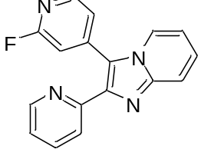
3-(2-Fluoropyridin-4-yl)-2-(pyridin-2-yl)imidazo[1,2-a]pyridine (OSA_000986).
3-Bromo-2-(pyridin-2-yl)imidazo[1,2-a]pyridine (100 mg, 0.365 mmol), (2-fluoropyridin-4-yl)boronic acid (67 mg, 0.475 mmol), and PdCl₂(dppf)∙CH₂Cl₂ (30 mg, 0.037 mmol) were combined in a microwave vial that was filled with argon and evacuated three times. A 2M aqueous Na₂CO₃ solution (0.75 ml, 1.50 mmol) was added, followed by the additon of 3:1 PhMe:EtOH (1.8 ml, 0.2 M). The reaction was run in the microwave at 120 ºC for 30 mins. The reaction was cooled to room temperature, diluted with EtOAc, filtered through celite, and concentrated. The crude material was purified by flash chromatography (1-10% MeOH:DCM), and the resulting dark orange solid was triturated with MeOH to afford the title compound as a light yellow solid (10 mg, 10%).
HRMS [M+H]⁺ 291.1052 m/z
¹H NMR (500 MHz, CHLOROFORM-d) δ ppm 7.05 (t, J=6.8 Hz, 1 H) 7.20 (s, 1 H) 7.25 - 7.29 (m, 1 H) 7.39 (dt, J=5.0, 1.6 Hz, 1 H) 7.51 (t, J=7.7 Hz, 1 H) 7.83 (td, J=7.7, 1.9 Hz, 1 H) 8.04 (d, J=8.8 Hz, 1 H) 8.14 (dt, J=5.0, 0.9 Hz, 1 H) 8.26 (d, J=7.9 Hz, 1 H) 8.42 (d, J=5.0 Hz, 1 H) 8.46 (dq, J=1.9, 0.9 Hz, 1 H)
¹³C NMR (500 MHz, CHLOROFORM-d) δ ppm 111.1, 111.4, 114.2, 118.0, 119.2-119.3 (d), 122.87-122.930 (d), 122.94, 123.2, 123.4, 127.0, 136.8, 142.89-142.96 (d), 145.0, 148.2-148.3 (d), 149.3, 163.2, 165.1
ELN Link: https://au-mynotebook.labarchives.com/share/Dana%2520Klug/NDEzLjQwMDAwMDAwMDAwMDAzfDY5Njg2LzMxOC9UcmVlTm9kZS8xNTUzNDM4ODkzfDEwNDkuMzk5OTk5OTk5OTk5OQ==
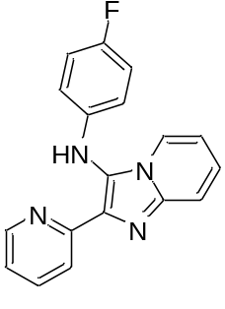
N-(4-Fluorophenyl)-2-(pyridin-2-yl)imidazo[1,2-a]pyridin-3-amine (OSA_000987).
Pyridin-2-amine (50 mg, 0.531 mmol) ytterbium(III) trifluoromethanesulfonate (10 mg, 0.016 mmol), picolinaldehyde (118 mg, 1.10 mmol), and 1-fluoro-4-isocyanobenzene (0.10 ml, 0.982 mmol) were combined in a microwave vial and heated to 115° C for 30 mins. The reaction mixture was then cooled to room temperature and the dark brown residue was dissolved in EtOAc. The organic layer was then washed once with water and once with brine, dried and with magnesium sulfate and concentrated. The crude material was purified by flash chromatography (20-100% EtOAc:Hex - 0-10% 5% NH4OH/MeOH:EtOAc), then repurified by reverse phase chromatography (0-100% MeOH:H₂O). The resulting brown solid was triturated with hot 1:1 MeOH:H₂O to afford a beige solid. This material was <95% pure by LCMS and was purified by flash chromatography (1-10% 5% NH₄OH/MeOH:DCM) to afford the title compound as a tan solid (38 mg, 24%).
HRMS [M+H]⁺ 305.1212 m/z
¹H NMR (400 MHz, METHANOL-d4) δ ppm 6.56 (m, J=9.1, 4.5 Hz, 2 H) 6.90 (m, J=8.7, 8.7 Hz, 2 H) 6.95 (td, J=6.8, 1.0 Hz, 1 H) 7.28 (ddd, J=7.5, 4.9, 1.0 Hz, 1 H) 7.37 (ddd, J=9.1, 6.8, 1.3 Hz, 1 H) 7.63 (d, J=9.1 Hz, 1 H) 7.83 (td, J=7.7, 1.8 Hz, 1 H) 7.90 (d, J=7.1 Hz, 1 H) 8.03 (d, J=7.8 Hz, 1 H) 8.60 (d, J=3.8 Hz, 1 H)
¹³C NMR (400 MHz, METHANOL-d4) δ ppm 114.0, 116.7, 117.0, 117.2 (d, J=8.0 Hz), 118.1, 122.8, 123.6, 124.8, 127.1, 138.2, 142.2, 143.5, 150.3, 154.1, 157.5, 159.9
ELN Link: https://au-mynotebook.labarchives.com/share/Dana%2520Klug/NDE0Ljd8Njk2ODYvMzE5L1RyZWVOb2RlLzUzODgyNzMyMXwxMDUyLjc=
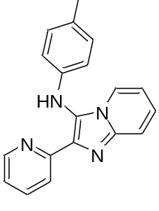
2-(Pyridin-2-yl)-N-(p-tolyl)imidazo[1,2-a]pyridin-3-amine (OSA_000988).
Pyridin-2-amine (25 mg, 0.266 mmol) ytterbium(III) trifluoromethanesulfonate (5 mg, 0.008 mmol), picolinaldehyde (50 μl, 0.523 mmol), and 1-isocyano-4-methylbenzene (65 mg, 0.555 mmol) were combined in a microwave vial and heated to 115° C for 30 mins. The reaction mixture was then cooled to room temperature and the dark brown residue was dissolved in EtOAc. The organic layer was then washed once with water and once with brine, dried and with magnesium sulfate and concentrated. The crude material was purified by flash chromatography (0-10% 5% NH₄OH/MeOH:EtOAc), then repurified by reverse phase chromatography (5-100% MeOH:H₂O) to afford the title compound as a bright yellow solid (12 mg, 15%).
HRMS [M+H]⁺ 301.1456 m/z
¹H NMR (500 MHz, METHANOL-d4) δ ppm 2.20 (s, 3 H) 6.46 (d, J=8.2 Hz, 2 H) 6.90 (t, J=6.8 Hz, 1 H) 6.97 (d, J=8.2 Hz, 2 H) 7.26 (dd, J=7.6, 5.0 Hz, 1 H) 7.34 (dd, J=8.4, 7.4 Hz, 1 H) 7.61 (d, J=9.1 Hz, 1 H) 7.78 - 7.85 (m, 2 H) 8.01 (d, J=8.2 Hz, 1 H) 8.59 (d, J=4.7 Hz, 1 H)
¹³C NMR (500 MHz, METHANOL-d4) δ ppm 20.6, 113.8, 116.2, 118.0, 122.8, 123.5, 125.0, 125.5, 127.0, 130.7, 131.0, 135.2, 138.2, 143.2, 143.3, 150.3, 154.2
ELN Link: https://au-mynotebook.labarchives.com/share/Dana%2520Klug/NDE5LjkwMDAwMDAwMDAwMDAzfDY5Njg2LzMyMy9UcmVlTm9kZS8zMTU4ODY3MjZ8MTA2NS44OTk5OTk5OTk5OTk5
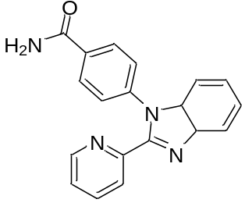
4-(2-(Pyridin-2-yl)-3a,7a-dihydro-1H-benzo[d]imidazol-1-yl)benzamide (OSA_000989).
2-(Pyridin-2-yl)-1H-benzo[d]imidazole (100 mg, 0.512 mmol), 4-bromobenzonitrile (0.100 ml, 0.813 mmol), 1,10-phenanthroline (21 mg, 0.116 mmol), Cs₂CO₃ (384 mg, 1.18 mmol), and CuI (15 mg, 0.079 mmol) were combined and dissolved in dry DMF (1.0 ml, 0.5 M) and refluxed at 100 ºC overnight. The reaction mixture was diluted with EtOAc and washed once with water and once with brine. The organic layer was dried with magnesium sulfate and concentrated. The crude material was purified by flash chromatography (1-10% MeOH:DCM) to afford the title compound as an off-white solid (38 mg, 24%).
HRMS [M+H]⁺ 315.1248 m/z
¹H NMR (500 MHz, DMSO-d₆) δ ppm 7.24 (dd, J=7.4, 1.1 Hz, 1 H) 7.31 - 7.38 (m, 2 H) 7.40 (ddd, J=7.6, 4.7, 1.3 Hz, 1 H) 7.46 (d, J=8.5 Hz, 2 H) 7.51 (s, 1 H) 7.85 (dd, J=7.3, 1.3 Hz, 1 H) 7.94 - 8.02 (m, 3 H) 8.12 (s, 1 H) 8.22 (dt, J=7.9, 0.9 Hz, 1 H) 8.33 (dq, J=2.2, 0.9 Hz, 1 H)
¹³C (500 MHz, DMSO-d₆) δ ppm 110.5, 119.8, 123.1, 124.1, 124.3, 124.6, 126.9, 128.6, 133.6, 136.9, 137.2, 139.8, 142.3, 148.6, 148.8, 150.2, 167.1
ELN Link: https://au-mynotebook.labarchives.com/share/Dana%2520Klug/NDI3Ljd8Njk2ODYvMzI5L1RyZWVOb2RlLzM2NDEyMzY5OTZ8MTA4NS43
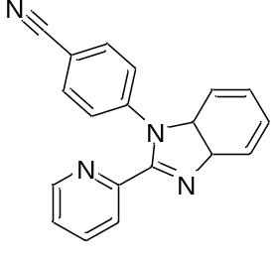
4-(2-(Pyridin-2-yl)-3a,7a-dihydro-1H-benzo[d]imidazol-1-yl)benzonitrile (OSA_000990).
2-(Pyridin-2-yl)-1H-benzo[d]imidazole (100 mg, 0.512 mmol), 4-bromobenzonitrile (0.100 ml, 0.813 mmol), 1,10-phenanthroline (21 mg, 0.116 mmol), Cs₂CO₃ (384 mg, 1.18 mmol), and CuI (15 mg, 0.079 mmol) were combined and dissolved in dry DMF (1.0 ml, 0.5 M) and refluxed at 100 ºC overnight. The reaction mixture was diluted with EtOAc and washed once with water and once with brine. The organic layer was dried with magnesium sulfate and concentrated. The crude material was purified by flash chromatography (1-10% MeOH:DCM). Then repurified by reverse phase chromatography (5-100% MeOH:H₂O) to afford the title compound as a light yellow solid (20 mg, 13%).
HRMS [M+H]⁺ 297.1141 m/z
¹H NMR (500 MHz, METHANOL-d₄) δ ppm 7.30 - 7.34 (m, 1 H) 7.36 - 7.45 (m, 3 H) 7.56 (d, J=8.5 Hz, 2 H) 7.82 - 7.86 (m, 1 H) 7.90 (d, J=8.5 Hz, 2 H) 7.96 (td, J=7.8, 1.7 Hz, 1 H) 8.13 - 8.18 (m, 1 H) 8.33 - 8.37 (m, 1 H)
¹³C NMR (500 MHz, METHANOL-d₄) δ ppm 111.9, 113.3, 119.1, 120.6, 125.2, 125.95, 126.04, 126.1, 129.7, 134.7, 138.0, 138.6, 142.8, 143.4, 149.6, 150.1, 151.8
ELN Link: https://au-mynotebook.labarchives.com/share/Dana%2520Klug/NDI3Ljd8Njk2ODYvMzI5L1RyZWVOb2RlLzM2NDEyMzY5OTZ8MTA4NS43
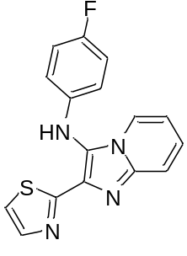
N-(4-Fluorophenyl)-2-(thiazol-2-yl)imidazo[1,2-a]pyridin-3-amine (OSA_001008).
Pyridin-2-amine (200 mg, 2.13 mmol) ytterbium(III) trifluoromethanesulfonate (66 mg, 0.106 mmol), thiazole-2-carbaldehyde (0.40 ml, 4.55 mmol), and 1-fluoro-4-isocyanobenzene (0.25 ml, 2.46 mmol) were combined in a microwave vial and heated to 115° C for 30 mins. The reaction mixture was then cooled to room temperature and the dark brown residue was dissolved in EtOAc. The organic layer was then washed once with water and once with brine, dried and with magnesium sulfate and concentrated. The crude material was purified by flash chromatography (20-100% EtOAc:Hex). The resulting dark brown solid was triturated with MeOH to afford the title compound as a tan solid (216 mg, 33%).
HRMS [M+H]⁺ 311.0769 m/z
¹H NMR (500 MHz, CHLOROFORM-d) δ ppm 6.59 - 6.67 (m, 2 H) 6.80 (t, J=6.6 Hz, 1 H) 6.91 - 6.99 (m, 2 H) 7.23 (ddd, J=9.0, 6.8, 0.9 Hz, 1 H) 7.31 (d, J=3.2 Hz, 1 H) 7.37 (br. s, 1 H) 7.63 (d, J=6.9 Hz, 1 H) 7.66 (d, J=9.1 Hz, 1 H) 7.83 (d, J=3.2 Hz, 1 H)
¹³C NMR (400 MHz, CHLOROFORM-d) δ ppm 112.6, 116.0, 116.2, 117.8 (d, J = 8.0 Hz), 118.2 (d, J = 8.8 Hz), 123.5, 123.6, 124.8, 139.1, 141.9, 143.5
ELN Link: https://au-mynotebook.labarchives.com/share/Dana%2520Klug/NDk2LjZ8Njk2ODYvMzgyL1RyZWVOb2RlLzM2MDI0NjA4NTd8MTI2MC42
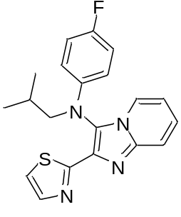
N-(4-Fluorophenyl)-N-isobutyl-2-(thiazol-2-yl)imidazo[1,2-a]pyridin-3-amine (OSA_001010).To a mixture of N-(4-fluorophenyl)-2-(thiazol-2-yl)imidazo[1,2-a]pyridin-3-amine (150 mg, 0.483 mmol) and Cs₂CO₃ (190 mg, 0.583 mmol) in DMF (3.2 mL, 0.15 M) was added 1-iodo-2-methylpropane (0.083 mL, 0.721 mmol). The reaction mixture was stirred overnight at room temperature. Reaction was incomplete by LCMS. The reaction temperature increased to 50 ºC and the reaction was stirred for another ~24 h. Starting material remained major peak, so the reaction temperature was further increased to 100 ºC and the reaction was run for another ~24 h. However, starting material remained the major peak. Additional 1-iodo-2-methylpropane (0.083 mL, 0.721 mmol) was added and the reaction was run at 100 ºC for another three days. Additional Cs₂CO₃ (190 mg, 0.583 mmol) was added and the temperature was lowered back to 50 ºC. The reaction was run for another ~24 h. The reaction was stopped and cooled to room temperature, then diluted with EtOAc. The organic layer was washed five times with water and once with brine, dried with sodium sulfate, and concentrated under vacuum. The crude material was purified by flash chromatography (20-100% EtOAc:Hex). Fractions containing desired pdt were concentrated, then triturated with MeOH to afford the title compound as a bright yellow solid (24 mg, 14%).
HRMS [M+H]⁺ 367.1397 m/z
¹H NMR (400 MHz, CHLOROFORM-d) δ ppm 0.68 - 1.16 (m, 6 H) 1.91 (dquin, J=13.5, 6.7, 6.7, 6.7, 6.7 Hz, 1 H) 3.74 (d, J=6.6 Hz, 2 H) 6.49 - 6.57 (m, 2 H) 6.83 (t, J=6.3 Hz, 1 H) 6.86 - 6.92 (m, 2 H) 7.28 (t, J=7.3 Hz, 1 H) 7.34 (d, J=3.3 Hz, 1 H) 7.69 (d, J=9.1 Hz, 1 H) 7.77 (d, J=6.8 Hz, 1 H) 7.87 (d, J=3.3 Hz, 1 H).
¹³C NMR (500 MHz, CHLOROFORM-d) δ ppm 20.9, 28.5, 61.1, 113.1, 115.0 (d, J=7.3 Hz), 116.0 (d, J=22 Hz), 118.2, 119.1, 123.0, 125.2, 126.0, 133.1, 142.2, 143.2, 144.3, 155.8, 157.7, 161.8
ELN Link: https://au-mynotebook.labarchives.com/share/Dana%2520Klug/NTAwLjV8Njk2ODYvMzg1L1RyZWVOb2RlLzIyMTc5Nzk1MjZ8MTI3MC41
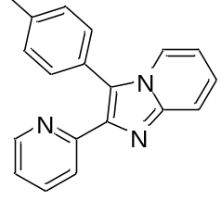
2-(Pyridin-2-yl)-3-(p-tolyl)imidazo[1,2-a]pyridine (OSA_001018).3-Bromo-7-chloro-2-(pyridin-2-yl)imidazo[1,2-a]pyridine (100 mg, 0.365 mmol), p-tolylboronic acid (59 mg, 0.434 mmol), and PdCl₂(dppf)∙CH₂Cl₂ (30 mg, 0.037 mmol) were combined in a microwave vial that was filled with argon and evacuated three times. A 2M aqueous Na₂CO₃ solution (0.90 ml, 1.80 mmol) was added, followed by the additon of 3:1 PhMe:EtOH (1.8 ml, 0.2 M). The reaction was run in the microwave at 120 ºC for 30 mins. The reaction was cooled to room temperature, diluted with MeOH, filtered through celite, and concentrated. The crude material was purified by flash chromatography (1-10% 5% NH4OH/MeOH:DCM), then by reverse phase chromatography (5-100% ACN:H2O) to afford the title compound as a tan solid (52 mg, 50%).
HRMS [M+H]⁺ 286.1346 m/z
¹H NMR (400 MHz, CHLOROFORM-d) δ ppm 2.46 (s, 3 H) 6.74 (td, J=6.8, 1.0 Hz, 1 H) 7.13 (ddd, J=7.3, 4.8, 1.3 Hz, 1 H) 7.20 (ddd, J=9.0, 6.8, 1.1 Hz, 1 H) 7.33 (d, J=7.8 Hz, 2 H) 7.39 (d, J=8.1 Hz, 2 H) 7.58 (td, J=6.1, 5.3 Hz, 1 H) 7.64 (d, J=7.8 Hz, 1 H) 7.71 (d, J=9.1 Hz, 1 H) 7.98 (d, J=6.8 Hz, 1 H) 8.60 (dq, J=2.3, 1.0 Hz, 1 H)
¹³C NMR (400 MHz, CHLOROFORM-d) δ ppm 21.5, 112.4, 118.1, 122.0, 122.7, 123.2, 123.6, 124.8, 126.6, 129.9, 130.6, 135.9, 138.8, 141.7, 144.9, 149.7, 153.4
ELN Link: https://au-mynotebook.labarchives.com/share/Dana%2520Klug/NTQ2LjB8Njk2ODYvNDIwL1RyZWVOb2RlLzE2ODczMjE4OTl8MTM4Ni4w
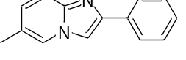

6-methyl-2-phenylimidazo[1,2-a]pyridine (OSA_1026) was prepared according to general procedure C. The product was purified by column chromatography (silica gel, using EtOAc/CyHex 40:60 v/v as mobile phase, hR_{f} = 0.40), giving the desired product as a yellowish solid (95% yield). MP: 168-170°C. ¹H NMR (300 MHz, CDCl₃) δ 7.97 – 7.91 (m, 2H), 7.87 (q, J = 1.2 Hz, 1H), 7.75 (s, 1H), 7.52 (d, J = 9.2 Hz, 1H), 7.46 – 7.38 (m, 2H), 7.36 – 7.27 (m, 1H), 7.00 (dd, J = 9.2, 1.6 Hz, 1H), 2.30 (d, J = 1.2 Hz, 3H). DEPT135 NMR (75 MHz, CDCl₃) δ 128.7, 127.9, 127.8, 125.9, 123.3, 116.8, 107.9, 18.1. ¹³C NMR (75 MHz, CDCl₃) δ 145.5, 144.8, 133.9, 128.7, 127.9, 127.9, 126.0, 123.4, 122.1, 116.87, 107.9, 18.1. HR-MS (+ESI) m/z: [M + H]⁺ calcd. for C₁₄H₁₃N₂⁺ 209.1073, found 209.1072.

ELN Link: https://tinyurl.com/yckjrut7

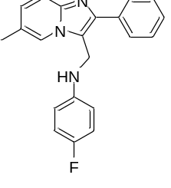

4-fluoro-N-({6-methyl-2-phenylimidazo[1,2-a]pyridin-3-yl}methyl)aniline (OSA_1027) was prepared according to general procedure D. The product was purified by column chromatography (silica gel, using EtOAc/Hex 40:60 v/v as mobile phase, hR_{f} = 0.37), giving the desired product as a yellowish solid (38% yield). ¹H NMR (300 MHz, DMSO-d₆) δ 8.16 (s, 1H), 7.82 – 7.75 (m, 2H), 7.55 (d, J = 9.2 Hz, 1H), 7.51 – 7.41 (m, 2H), 7.40 – 7.32 (m, H), 7.17 (dd, J = 9.2, 1.6 Hz, 1H), 6.95 (dd, J = 9.9, 7.9 Hz, 2H), 6.67 (dd, J = 9.0, 4.5 Hz, 2H), 6.07 (t, J = 4.8 Hz, 1H), 4.55 (d, J = 4.8 Hz, 2H), 2.31 (s, 3H). DEPT135 NMR (75 MHz, DMSO-d₆) δ 128.60, 127.93, 127.85, 127.59, 122.41, 116.19, 115.29 (d, J = 22.0 Hz), 113.31 (d, J = 7.3 Hz), 37.53, 17.77. ¹³C NMR (75 MHz, DMSO-d₆) δ 154.71 (d, J = 231.5 Hz), 145.27 (d, J = 1.2 Hz), 143.22, 143.12, 134.53, 128.60, 127.94, 127.85, 127.59, 122.42, 121.39, 117.07, 116.19, 115.29 (d, J = 21.9 Hz), 113.32 (d, J = 7.3 Hz), 37.54, 17.78. HR-MS (+ESI) m/z: [M + H]⁺ calcd. for C₂₁H₁₉FN₃⁺ 332,1558, found 332.1547.
ELN Link: https://tinyurl.com/28w5u2fr

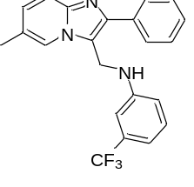

N-[(6-methyl-2-phenylimidazo[1,2-a]pyridin-3-yl)methyl]-3-(trifluoromethyl)aniline (OSA_1028) was prepared according to general procedure D. The product was purified by column chromatography (silica gel, using EtOAc/Hex 50:50 v/v as mobile phase, hR_{f} = 0.38), giving the desired product as a brownish solid (45% yield). MP: 213-218°C. ¹H NMR (300 MHz, Acetic acid-d₄) δ 8.61 (s, 1H), 7.94 (d, J = 9.2 Hz, 1H), 7.81 – 7.71 (m, 3H), 7.63 – 7.50 (m, 3H), 7.21 (t, J = 7.8 Hz, 1H), 6.92 (d, J = 7.6 Hz, 1H), 6.86 – 6.76 (m, J = 8.6 Hz, 2H), 4.84 (s, 2H), 2.45 (s, 3H). DEPT135 ¹³C NMR (75 MHz, Acetic acid-d₄) δ 137.7, 132.3, 131.5, 131.2, 130.6, 126.4, 118.3, 115.9, 113.9, 110.5, 37.9, 18.9. ¹³C NMR (75 MHz, Acetic acid-d₄) δ 149.6, 140.6, 137.7, 136.7, 133.1, 132.7, 132.3, 131.5, 131.2, 130.6, 129.7, 128.3, 126.4, 124.4, 120.6, 118.3, 116.0, 113.9, 110.5, 37.9, 18.9. HR-MS (+ESI) m/z: [M + H]⁺ calcd. for C₂₂H₁₉F₃N₃⁺ 382.1525, found 382.1525.
ELN Link: https://tinyurl.com/y6eukwk4

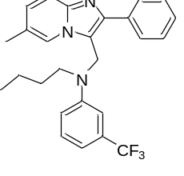

N-butyl-N-({6-methyl-2-phenylimidazo[1,2-a]pyridin-3-yl}methyl)-3-(trifluoromethyl)aniline (OSA_1029). N-alkylation of the aniline was prepared according to general procedure E. Then, the final product was obtained according to general procedure D. The product was purified by column chromatography (silica gel, using MeOH/DCM 1:99 v/v as mobile phase, hR_{f} = 0.41), giving the desired product as a yellowish solid (40% yield). ¹H NMR (300 MHz, DMSO-d₆) δ 8.87 (s, 1H), 8.36 (d, J = 9.3 Hz, 1H), 8.04 (dd, J = 9.3, 1.4 Hz, 1H), 7.75 – 7.63 (m, 4H), 7.22 (t, J = 7.9 Hz, 1H), 6.86 (d, J = 7.7 Hz, 1H), 6.76 – 6.67 (m, 2H), 6.67 – 6.59 (m, 1H), 4.57 (d, J = 5.1 Hz, 2H), 4.37 (t, J = 7.2 Hz, 2H), 1.48 (p, J = 7.5 Hz, 2H), 1.22 (s, 3H), 1.08 (p, J = 7.4 Hz, 2H), 0.66 (t, J = 7.3 Hz, 3H). DEPT135 ¹³C NMR (75 MHz, DMSO-d₆) δ 136.24, 130.72, 130.29, 129.61, 129.14, 125.19, 116.01, 112.68, 110.60, 107.53, 44.04, 35.29, 30.45, 18.53, 17.25, 12.90. ¹³C NMR (75 MHz, DMSO-d₆) δ 147.94, 137.60, 136.49, 134.96, 130.97, 130.54, 129.86, 129.39, 127.68, 125.44, 124.69, 122.52, 120.56, 116.26, 112.95, 110.86, 107.78, 44.30, 35.54, 30.71, 18.78, 17.50, 13.15. HR-MS (+ESI) m/z: [M + H]⁺ calcd. for C₂₆H₂₇F₃N₃⁺ 438.2152, found 438.2123.
ELN Link: https://tinyurl.com/2p8duyh7

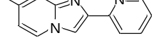

2-{7-methylimidazo[1,2-a]pyridin-2-yl}pyridine (OSA_1030) was prepared according to general procedure C. The product was purified by column chromatography (silica gel, using EtOAc/Hex 90:10 v/v as mobile phase, hR_{f} = 0.10), giving the desired product as a white solid (60% yield). ¹H NMR (300 MHz, DMSO-d₆) δ 8.58 (ddd, J = 4.8, 1.8, 0.9 Hz, 1H), 8.46 (d, J = 6.9 Hz, 1H), 8.38 (s, 1H), 8.08 (dt, J = 7.9, 1.2 Hz, 1H), 7.86 (td, J = 7.7, 1.8 Hz, 1H), 7.37 (s, 1H), 7.30 (ddd, J = 7.5, 4.8, 1.2 Hz, 1H), 6.77 (dd, J = 6.9, 1.6 Hz, 1H), 2.35 (s, 3H). DEPT135 ¹³C NMR (75 MHz, DMSO-d₆) δ 149.86, 137.39, 126.87, 123.08, 120.15, 115.57, 115.54, 111.23, 21.34. ¹³C NMR (75 MHz, DMSO-d₆) δ 152.98, 149.43, 145.24, 144.44, 136.96, 135.80, 126.45, 122.65, 119.72, 115.14, 115.11, 110.80, 20.91. HR-MS (+ESI) m/z: [M + H]⁺ calcd. for C₁₃H₁₂N₃⁺ 210.1026, found 210.1011.
ELN Link: https://tinyurl.com/aaubaujh

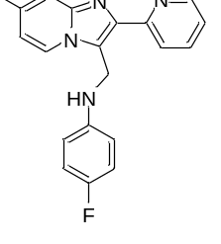

4-fluoro-N-{[7-methyl-2-(pyridin-2-yl)imidazo[1,2-a]pyridin-3-yl]methyl}aniline (OSA_1031) was prepared according to general procedure D. The product was purified by column chromatography (silica gel, using EtOAc/Hex 80:20 v/v as mobile phase, hR_{f} = 0.30), giving the desired product as a gray solid (35% yield). ¹H NMR (300 MHz, DMSO-d₆) δ 8.66 (dd, J = 5.0, 1.9 Hz, 1H), 8.39 (d, J = 7.0 Hz, 1H), 8.21 (d, J = 8.0 Hz, 1H), 7.90 (td, J = 7.7, 1.9 Hz, 1H), 7.38 (s, 1H), 7.33 (ddd, J = 7.6, 4.8, 1.2 Hz, 1H), 6.87 – 6.76 (m, 3H), 6.74 – 6.64 (m, 2H), 6.10 (s, 1H), 5.16 (s, 2H), 2.36 (s, 3H). DEPT135 ¹³C NMR (75 MHz, DMSO-d₆) δ 148.76, 136.75, 124.56, 122.04, 121.51, 115.07, 114.92, 114.73 (d, J = 7.1 Hz), 113.08 (d, J = 7.3 Hz), 36.89, 20.56. ¹³C NMR (75 MHz, DMSO-d₆) δ 154.44 (d, J = 231.3 Hz), 154.50, 149.00, 145.23 (d, J = 1.3 Hz), 144.30, 140.26, 136.99, 135.75, 124.81, 122.28, 121.76, 120.08, 115.31, 115.16, 114.97 (d, J = 7.0 Hz), 113.33 (d, J = 7.3 Hz). HR-MS (+ESI) m/z: [M + Na]⁺ calcd. for C₂₀H₁₈FN₄⁺Na 356.1402, found 355.1296.
ELN Link: https://tinyurl.com/yp2bpmjs
.

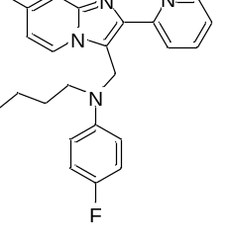

N-butyl-4-fluoro-N-{[7-methyl-2-(pyridin-2-yl)imidazo[1,2-a]pyridin-3-yl]methyl}aniline (OSA_1032). N-alkylation of the aniline was prepared according to general procedure E. Then, the final product was obtained according to general procedure D. The product was purified by column chromatography (silica gel, using EtOAc/Hex 40:60 v/v as mobile phase, hR_{f} = 0.21), giving the desired product as a brown solid (70% yield). ¹H NMR (300 MHz, Chloroform-d) δ 8.71 – 8.54 (m, 1H), 8.25 (dd, J = 7.8, 1.4 Hz, 1H), 7.95 (d, J = 7.0 Hz, 1H), 7.78 (td, J = 7.8, 1.9 Hz, 1H), 7.40 (s, 1H), 7.24 – 7.15 (m, 1H), 7.01 – 6.82 (m, 4H), 6.59 (dd, J = 7.1, 1.7 Hz, 1H), 5.25 (s, 2H), 3.12 – 3.02 (m, 2H), 2.38 (s, 3H), 1.41 – 1.27 (m, 2H), 1.03 (h, J = 7.3 Hz, 2H), 0.67 (t, J = 7.3 Hz, 3H). DEPT135 ¹³C NMR (75 MHz, Chloroform-d) δ 148.73, 136.58, 124.45, 122.24 (d, J = 18.8 Hz), 117.78 (d, J = 7.4 Hz), 115.70, 115.69, 115.39, 115.25, 50.92, 44.40, 27.88, 21.37, 20.12, 13.73. ¹³C NMR (75 MHz, Chloroform-d) δ 156.45 (d, J = 237.5 Hz), 154.32, 148.72, 146.24 (d, J = 2.1 Hz), 145.16, 141.85, 136.57, 136.22, 124.45, 122.23 (d, J = 19.4 Hz), 119.25, 117.79 (d, J = 7.4 Hz), 115.70, 115.68, 115.39, 115.24, 50.92, 44.41, 27.89, 21.36, 20.12, 13.72. HR-MS (+ESI) m/z: [M + H]⁺ calcd. for C₂₄H₂₆FN₄⁺ 389.2136, found 389.2120.
ELN Link: https://tinyurl.com/3t84wh49
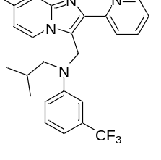

N-{[7-methyl-2-(pyridin-2-yl)imidazo[1,2-a]pyridin-3-yl]methyl}-N-(2-methylpropyl)-3-(trifluoromethyl)aniline (OSA_1033). N-alkylation of the aniline was prepared according to general procedure E. Then, the final product was obtained according to general procedure D. The product was purified by column chromatography (silica gel, using EtOAc/CyHex 40:60 v/v as mobile phase, hR_{f} = 0.40), giving the desired product as a white solid (39% yield). ¹H NMR (300 MHz, Acetone-d₆) δ 8.68 (dq, J = 4.8, 1.9, 1.2 Hz, 1H), 8.36 (dt, J = 8.0, 1.0 Hz, 1H), 7.99 (dd, J = 7.0, 0.9 Hz, 1H), 7.90 (td, J = 7.8, 1.8 Hz, 1H), 7.38 (s, 1H), 7.35 – 7.27 (m, 4H), 6.91 – 6.86 (m, 1H), 6.74 (dd, J = 7.1, 1.8 Hz, 1H), 5.67 (s, 2H), 3.40 (d, J = 7.3 Hz, 2H), 2.36 (d, J = 1.1 Hz, 3H), 2.07 – 2.02 (m, 1H), 0.82 (s, 3H), 0.80 (s, 31H). DEPT135 ¹³C NMR (75 MHz, Acetone-d₆) δ 149.30, 137.21, 137.00, 130.18, 125.18, 122.75, 118.95, 116.36, 115.64, 113.74, 111.72, 58.92, 46.16, 27.21, 20.88, 20.29. ¹³C NMR (75 MHz, Acetone-d₆) δ 155.97, 150.21, 149.55, 145.96, 142.68, 137.46, 136.62, 132.62 – 130.73 (m), 130.43, 125.43, 123.00, 119.79, 119.20, 116.61, 115.89, 113.97 (d, J = 3.8 Hz), 112.02, 59.17, 46.36, 27.46, 21.14, 20.54. HR-MS (+ESI) m/z: [M + H]⁺ calcd. for C₂₅H₂₆F₃N₄⁺ 439.2104, found 439.2086.
ELN Link: https://tinyurl.com/2p8m5xru

Appendix
Representative well-resolved ¹H NMR, DEPT135 and proton-decoupled ¹³C NMR spectras

OSA_1026 | 6-methyl-2-phenylimidazo[1,2-a]pyridine

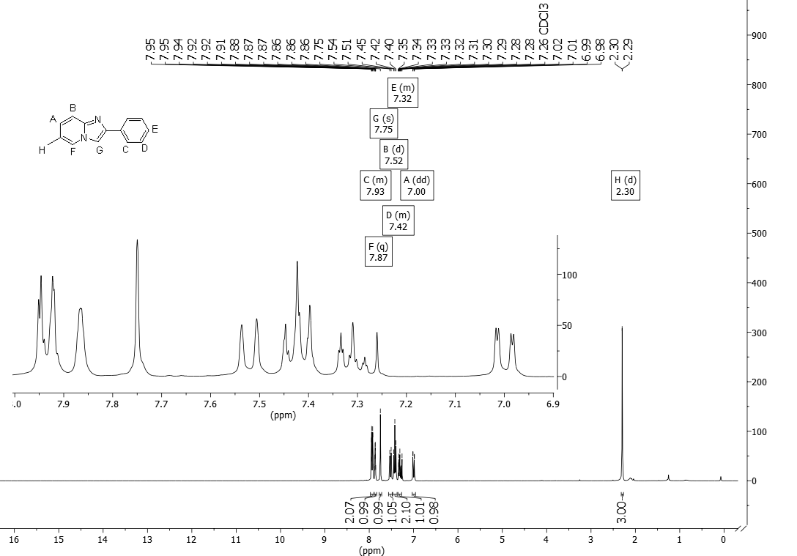
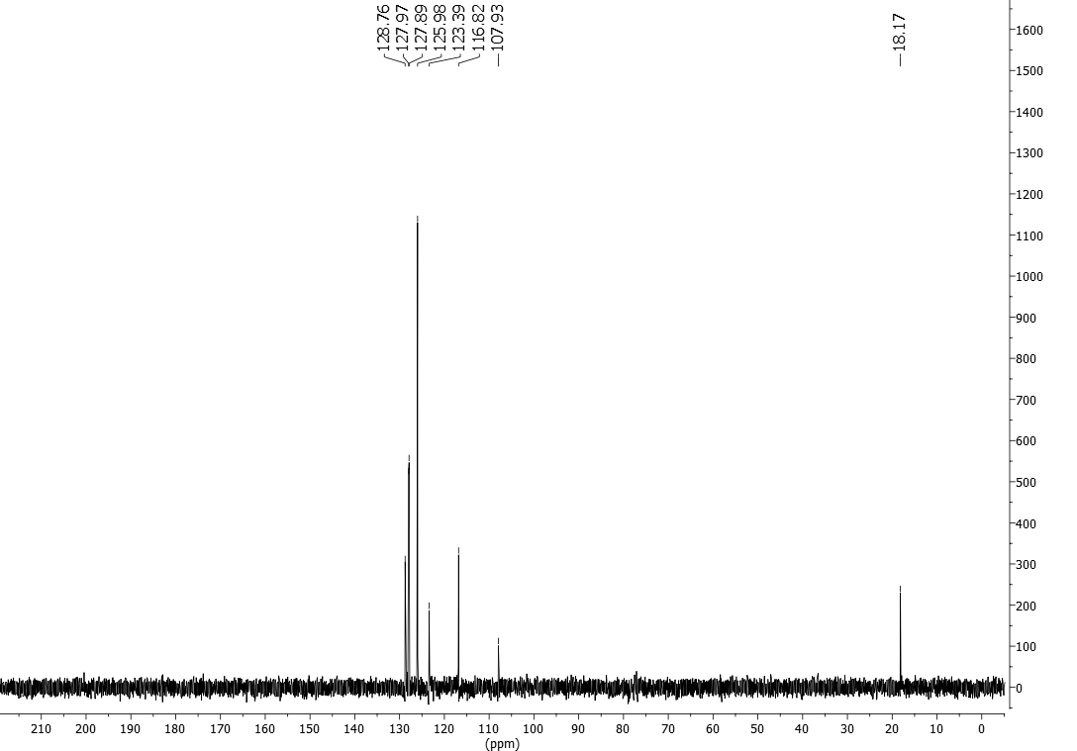
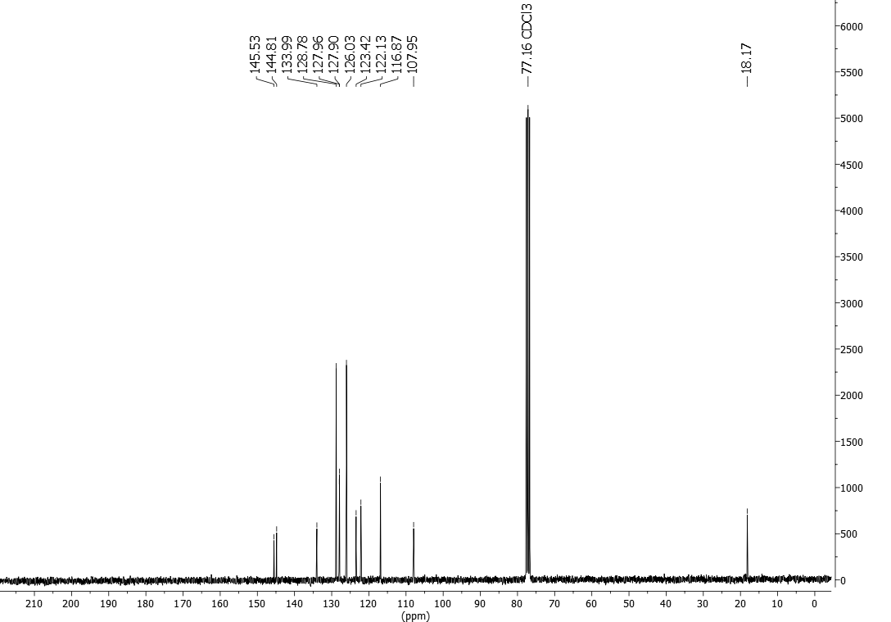

OSA_1027 | 4-fluoro-N-({6-methyl-2-phenylimidazo[1,2-a]pyridin-3-yl}methyl)aniline

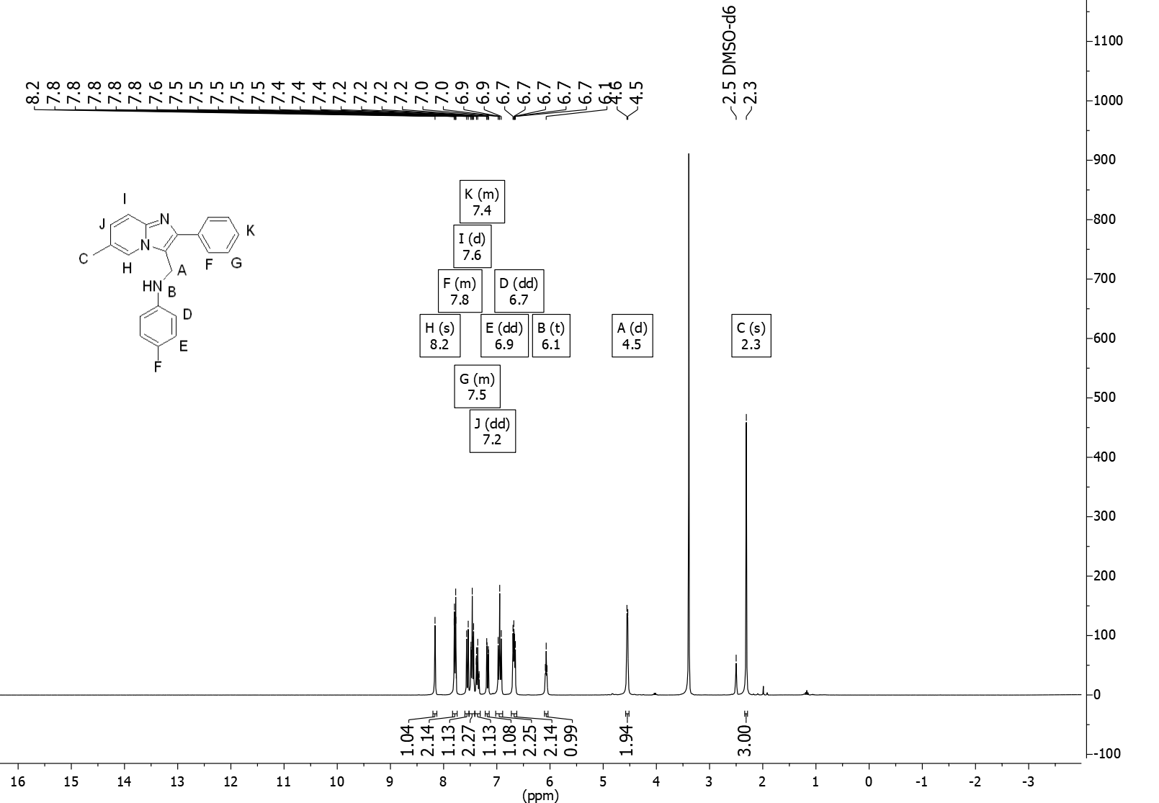
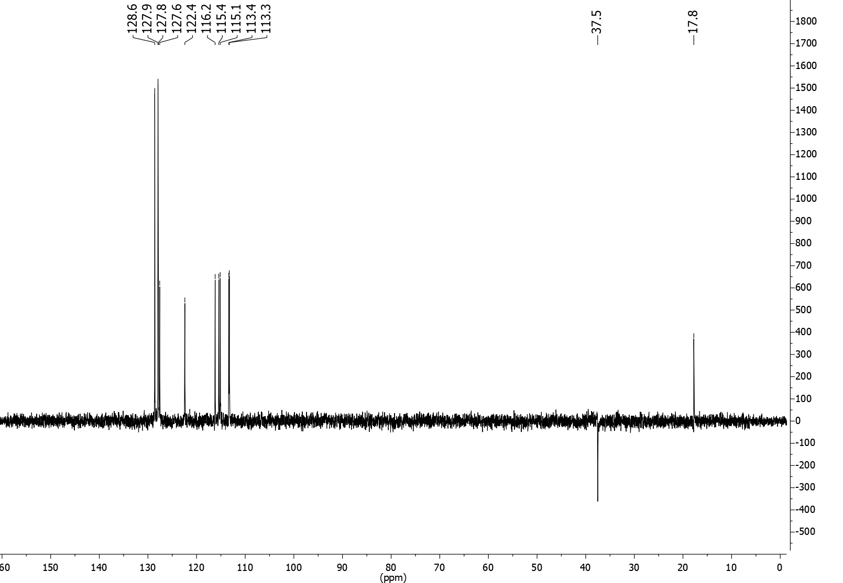
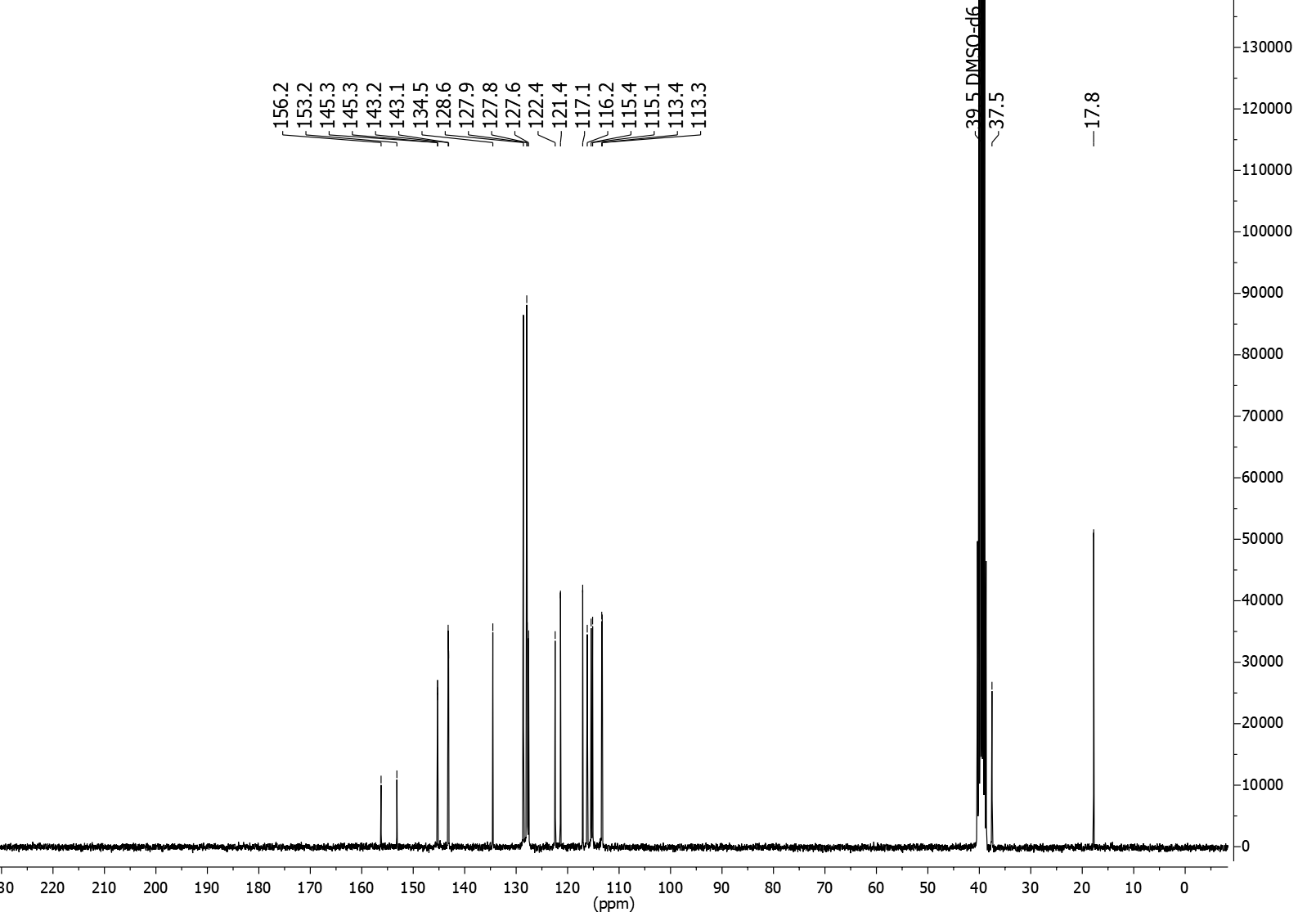

OSA_1028 | N-[(6-methyl-2-phenylimidazo[1,2-a]pyridin-3-yl)methyl]-3-(trifluoromethyl)aniline

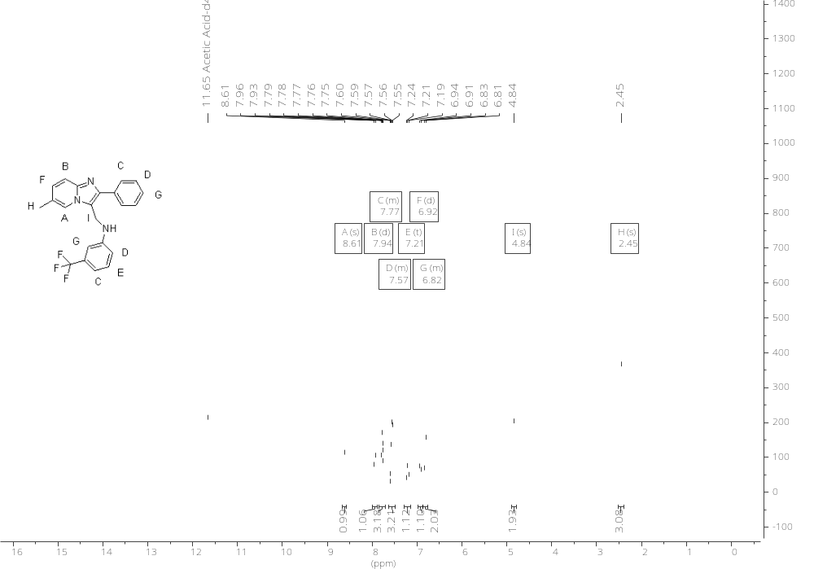
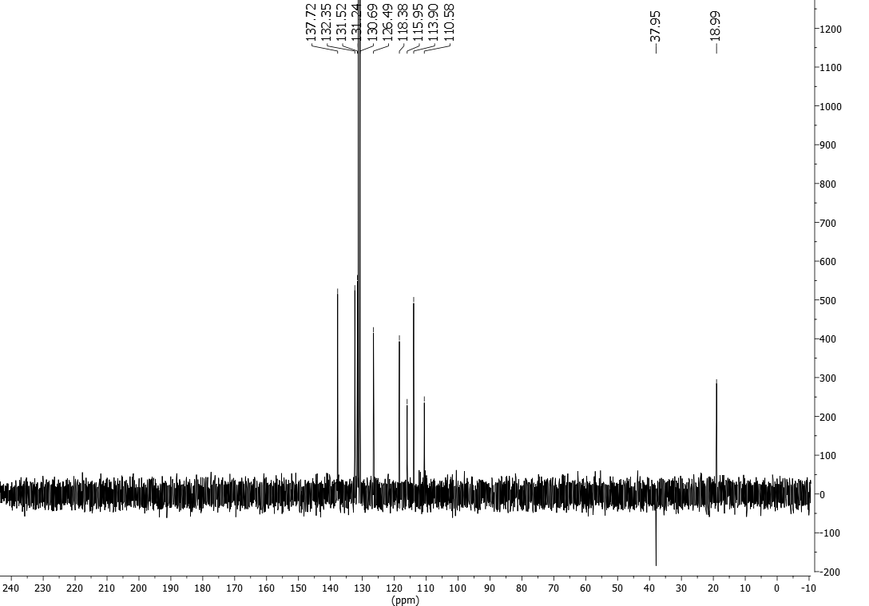
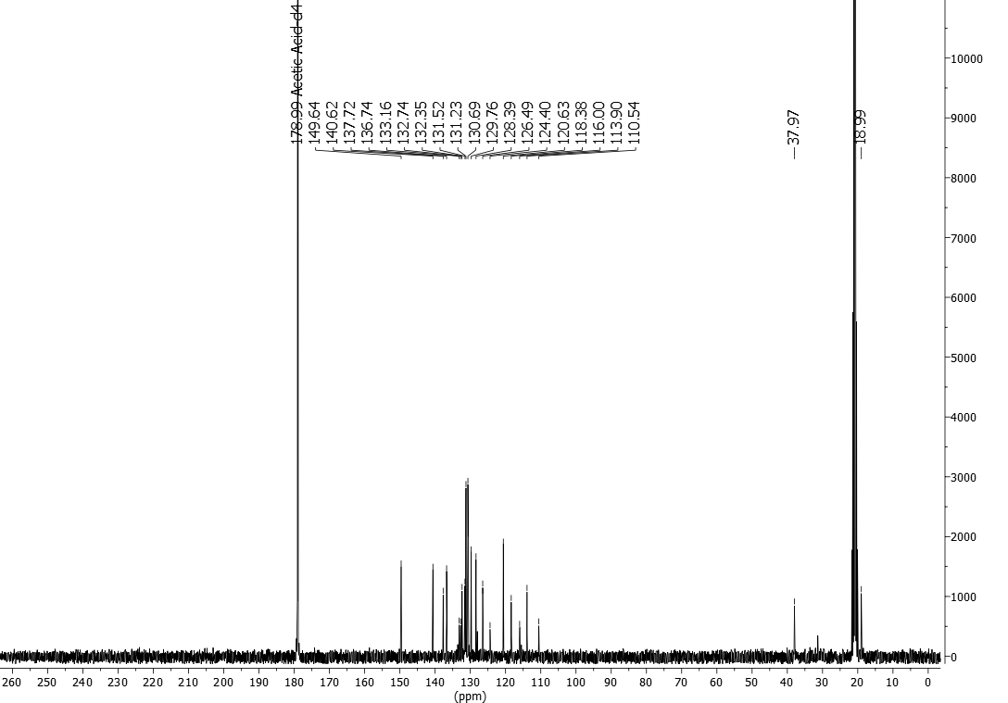

OSA_1029 | N-butyl-N-({6-methyl-2-phenylimidazo[1,2-a]pyridin-3-yl}methyl)-3-(trifluoromethyl)aniline
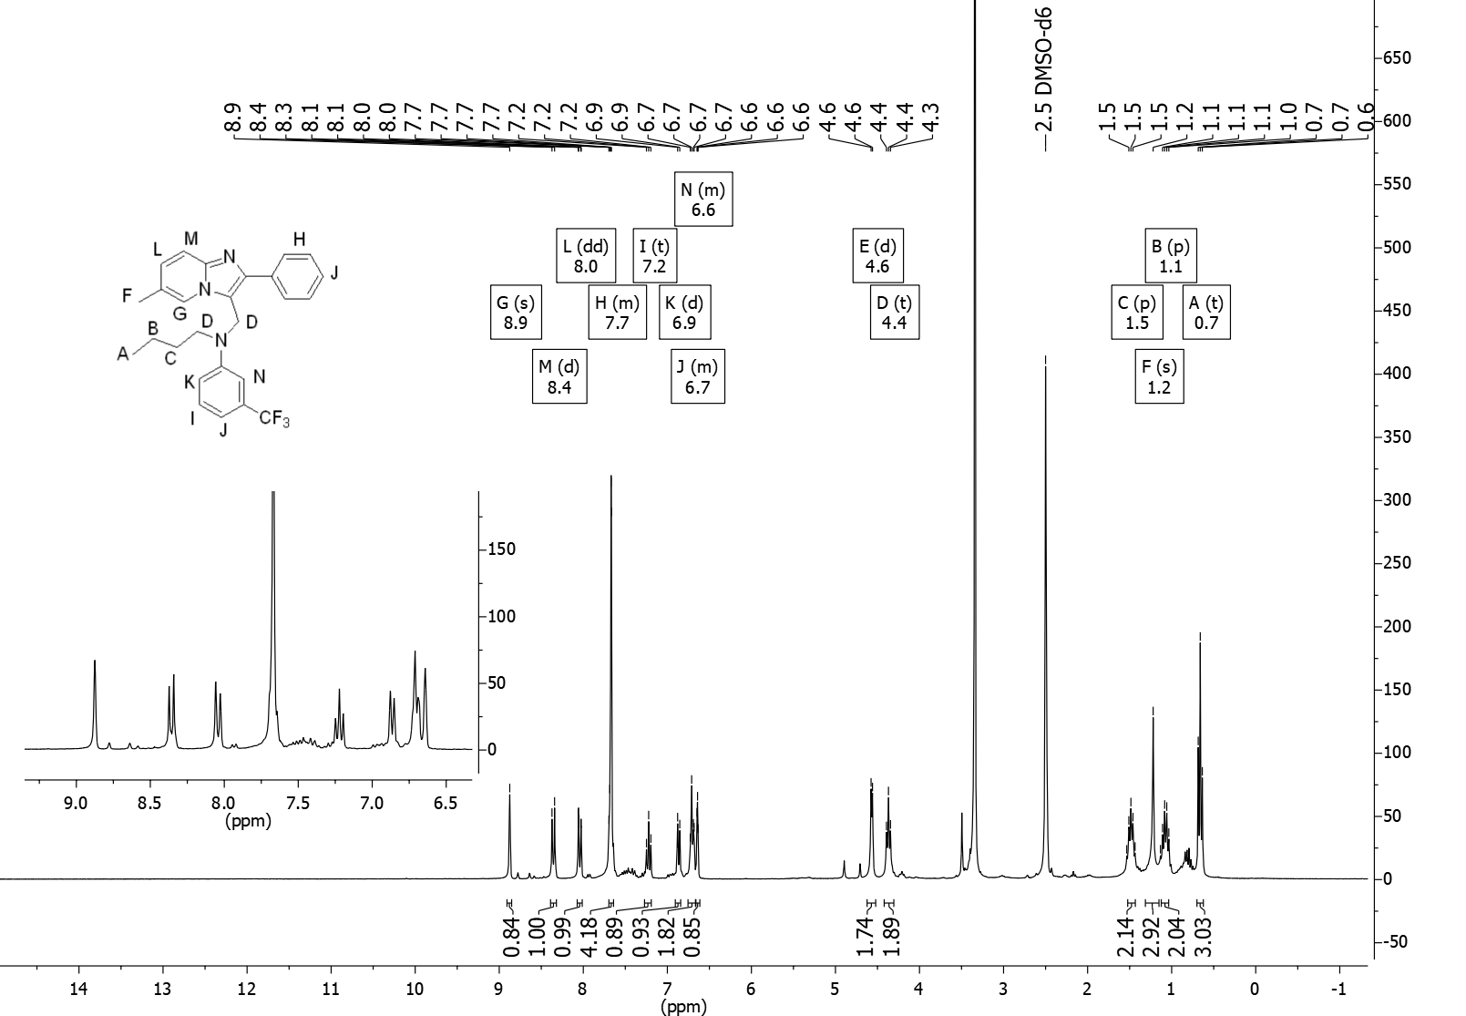
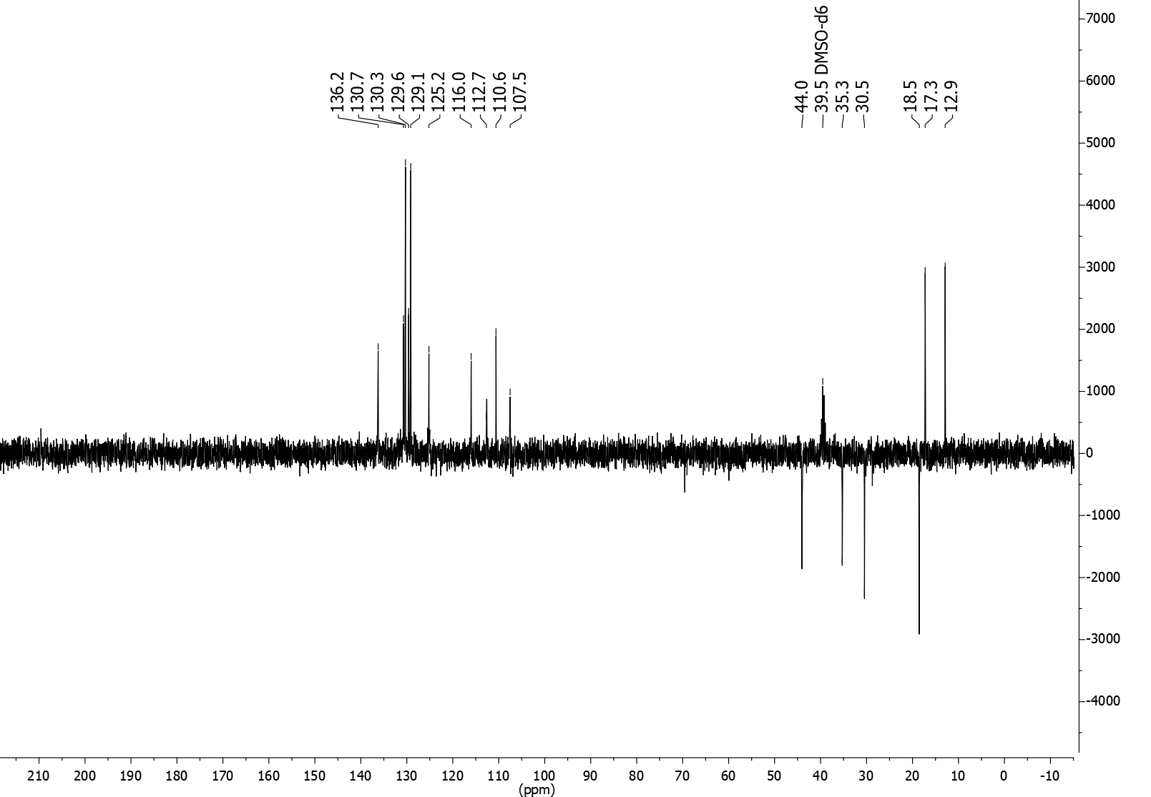
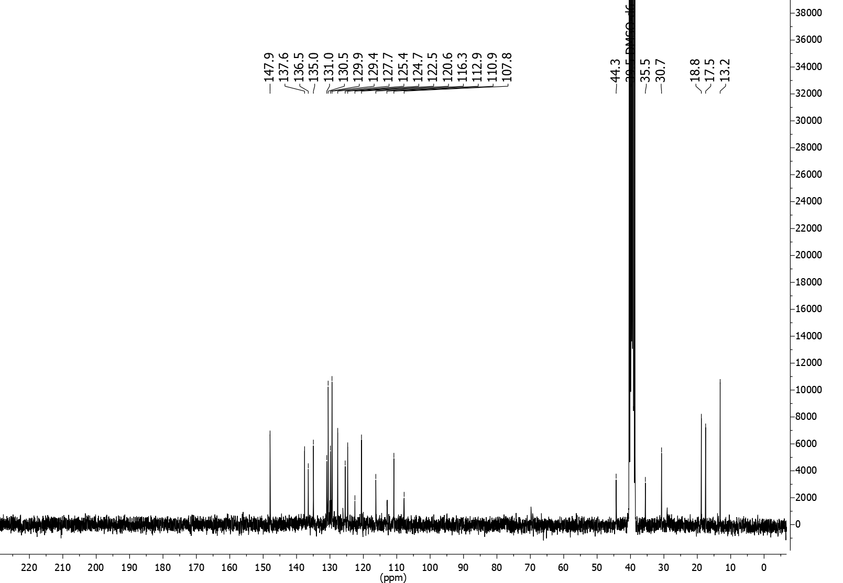

OSA_1030 | 2-{7-methylimidazo[1,2-a]pyridin-2-yl}pyridine
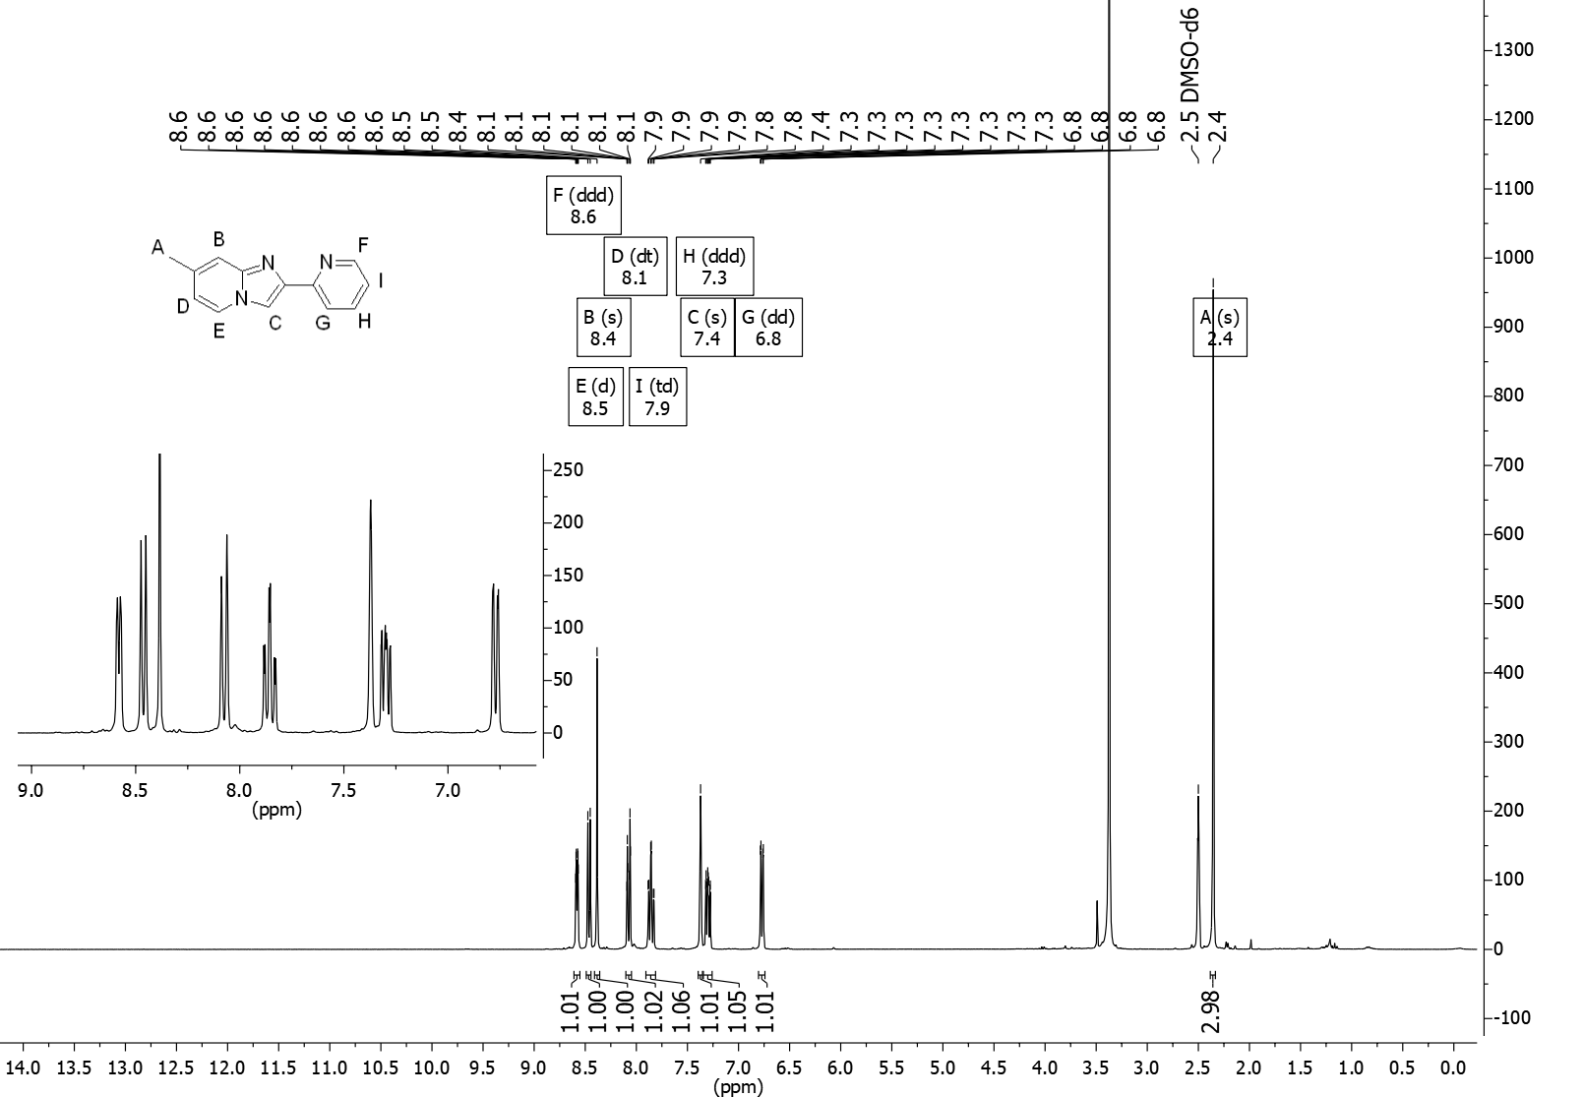

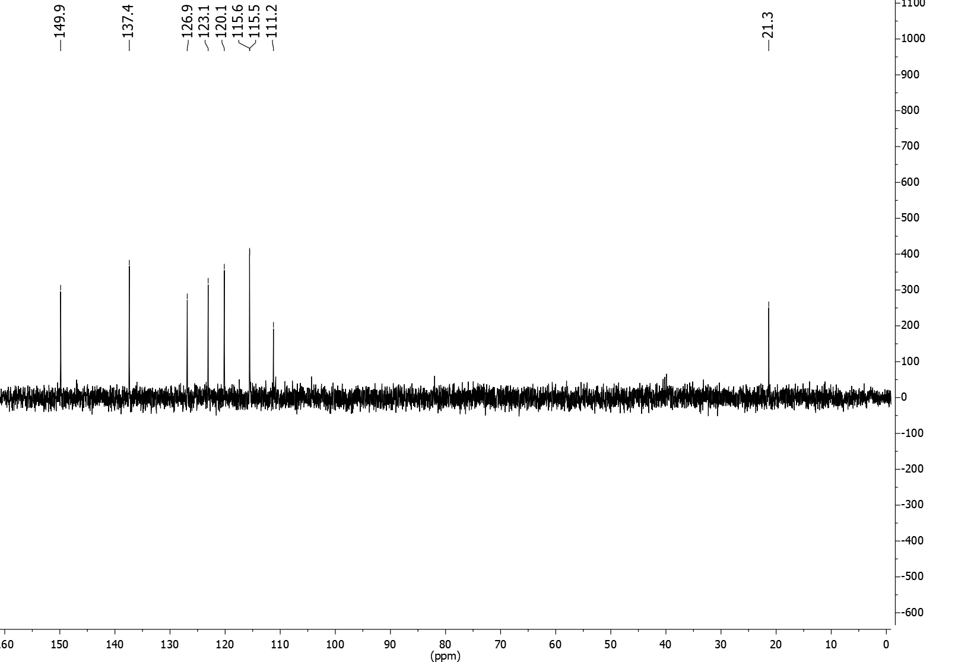
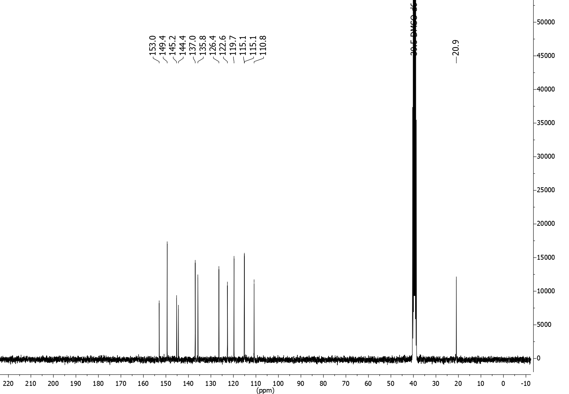

OSA_1031 | 4-fluoro-N-{[7-methyl-2-(pyridin-2-yl)imidazo[1,2-a]pyridin-3-yl]methyl}aniline
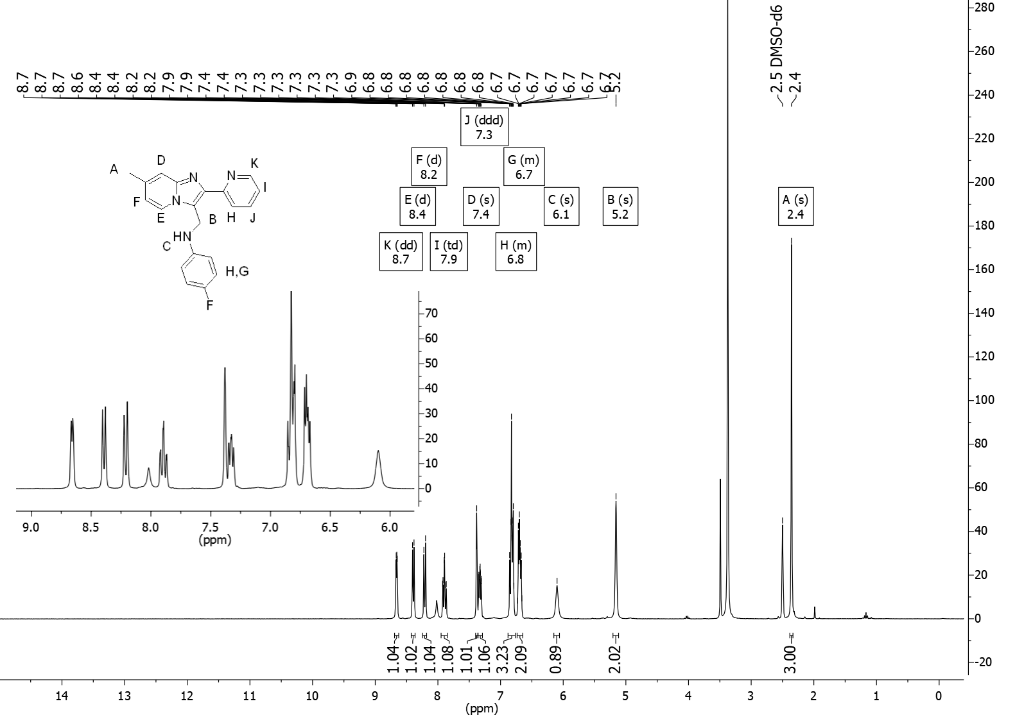

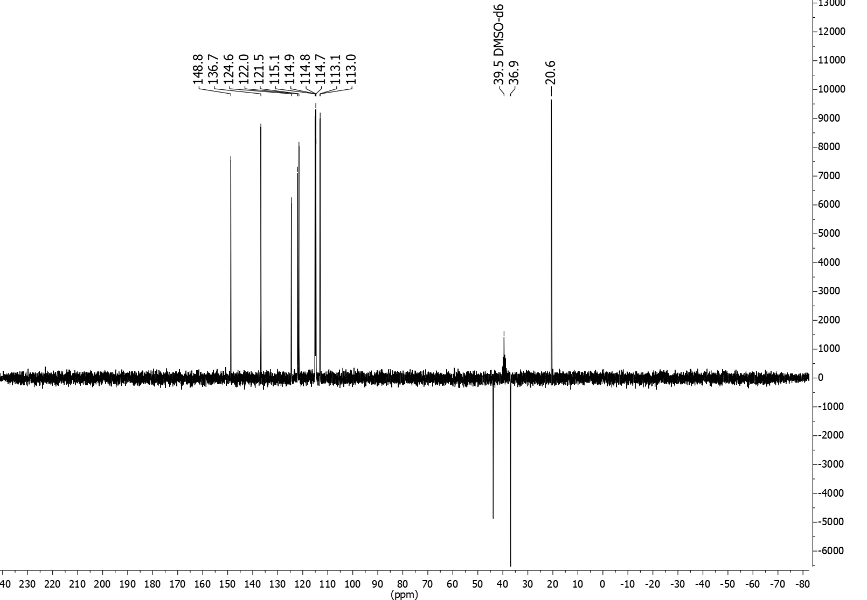

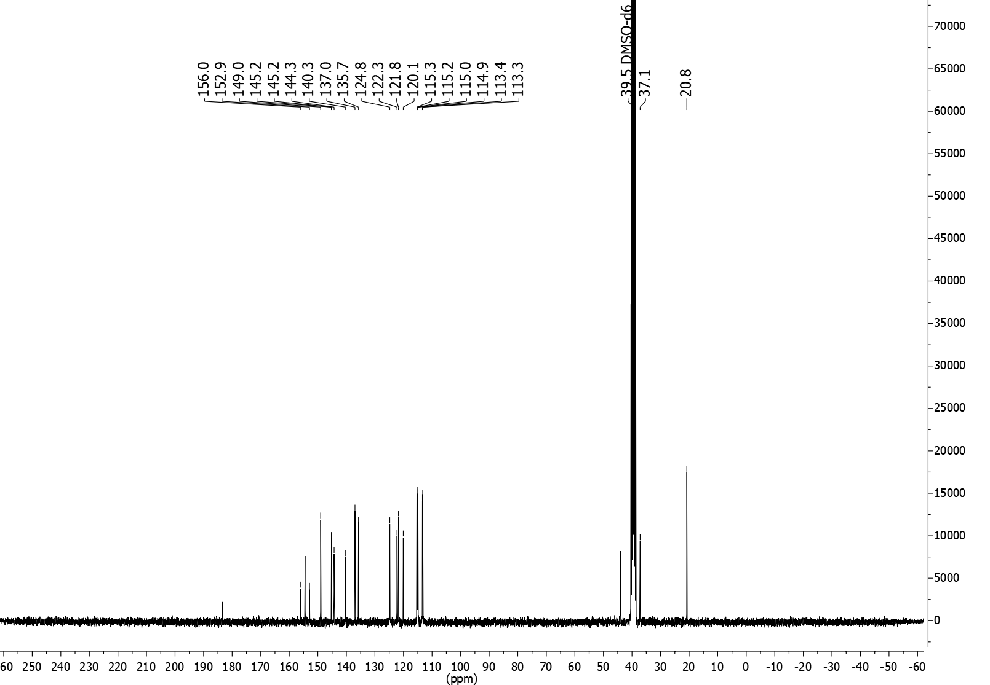

OSA_1032 | N-butyl-4-fluoro-N-{[7-methyl-2-(pyridin-2-yl)imidazo[1,2-a]pyridin-3-yl]methyl}aniline

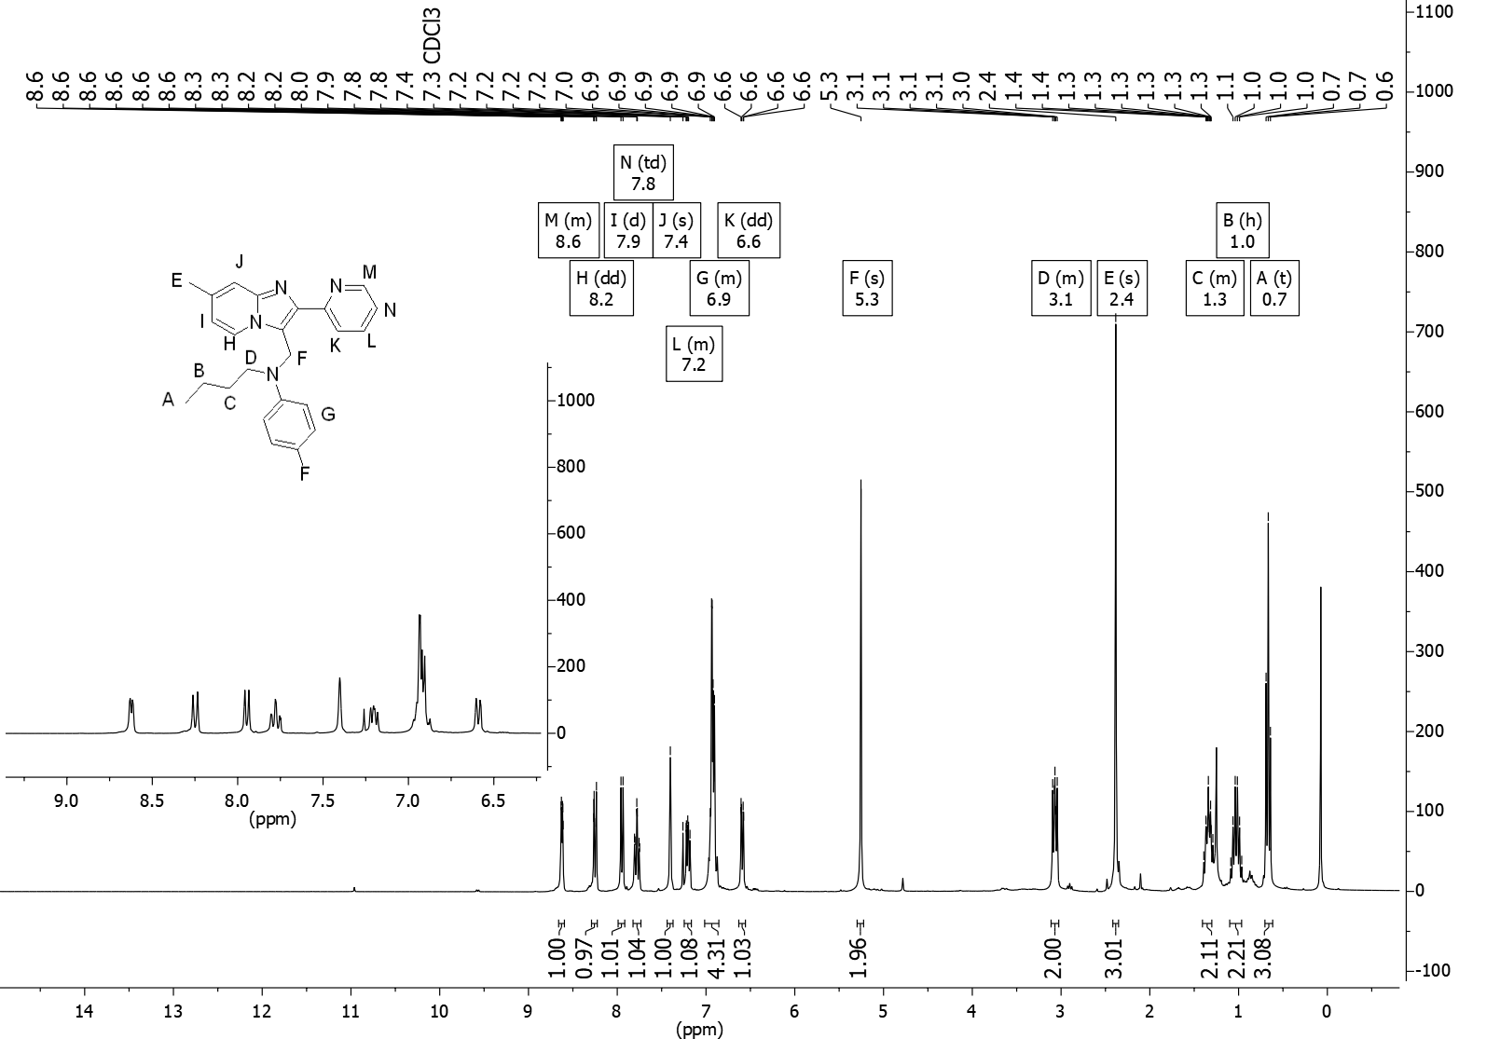
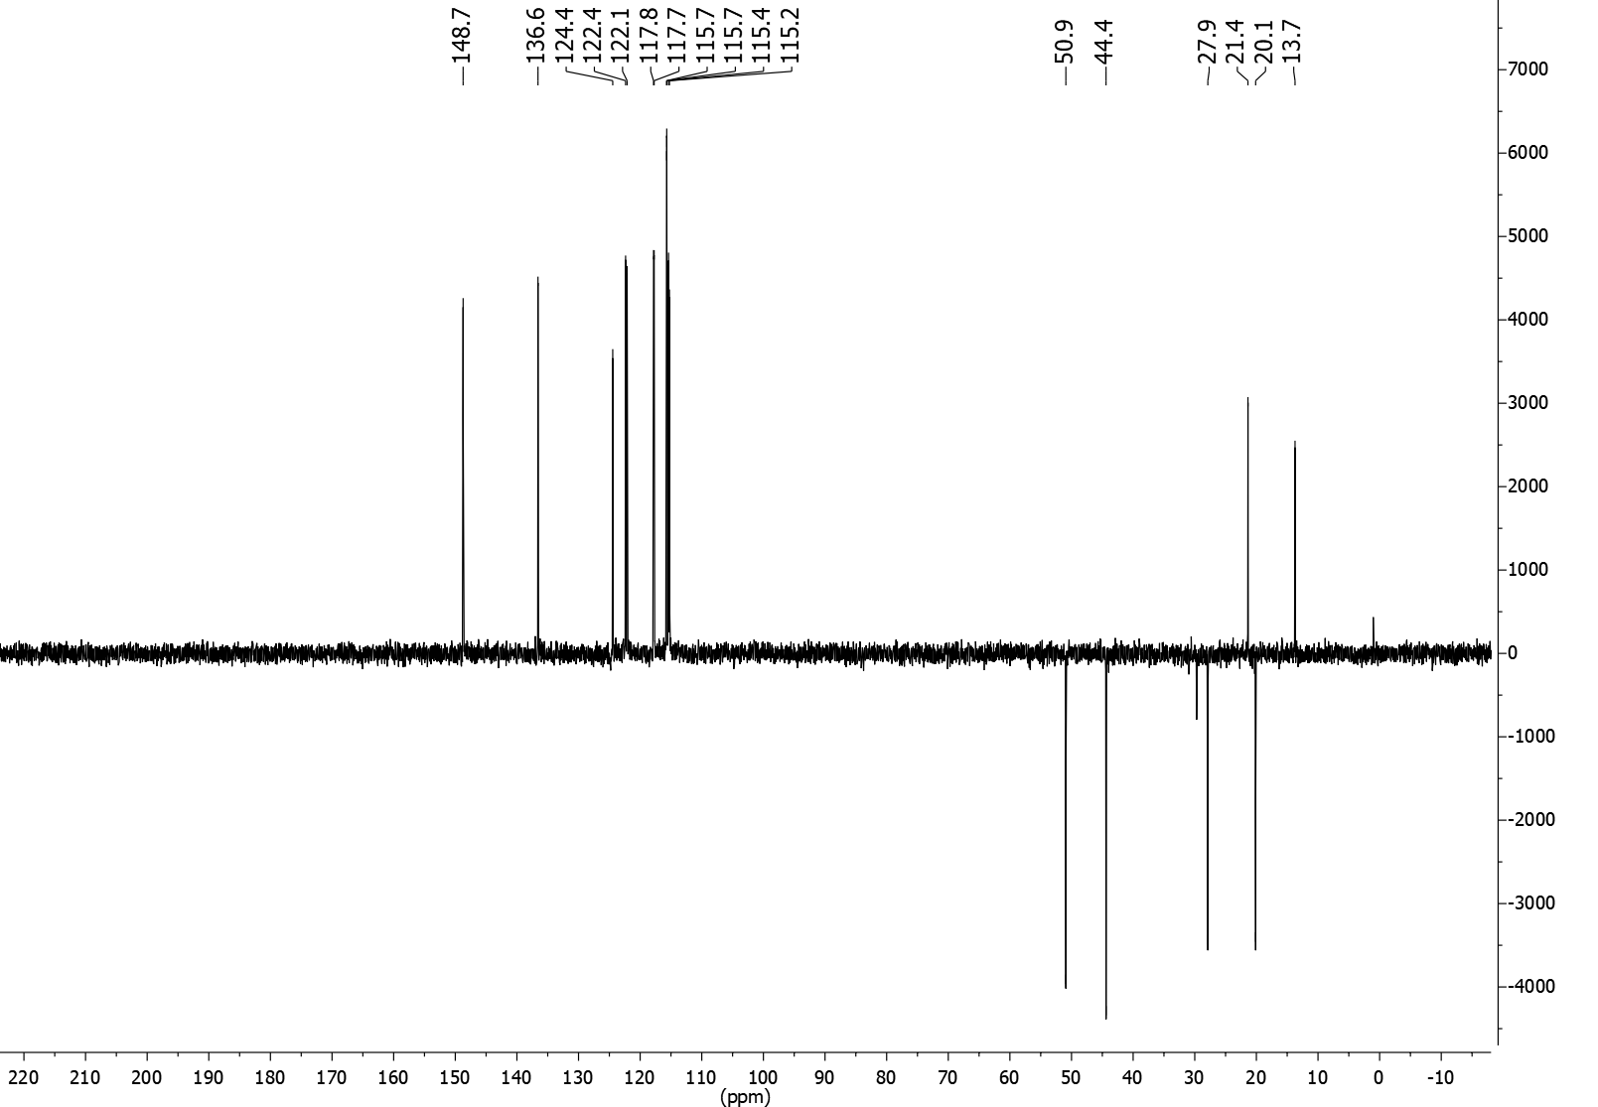
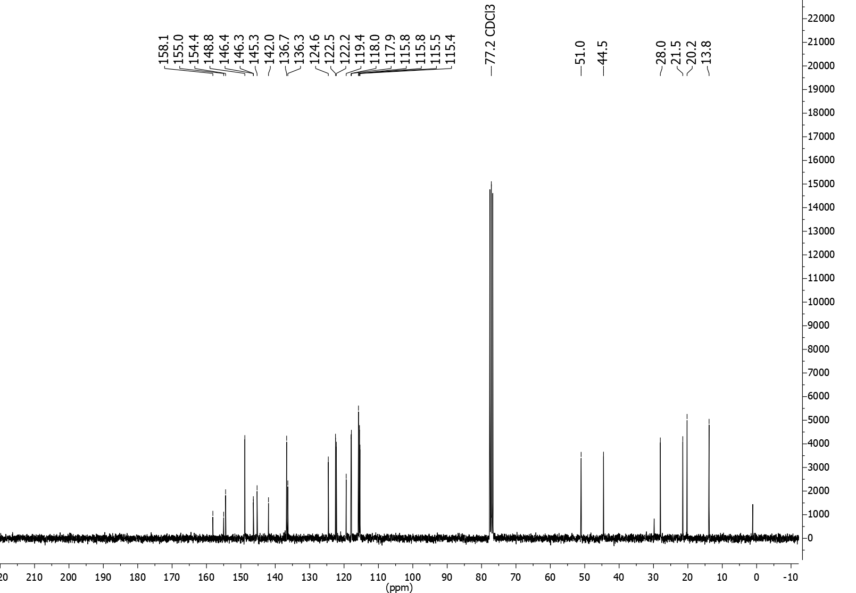

OSA_1033 | N-{[7-methyl-2-(pyridin-2-yl)imidazo[1,2-a]pyridin-3-yl]methyl}-N-(2-methylpropyl)-3-(trifluoromethyl)aniline
